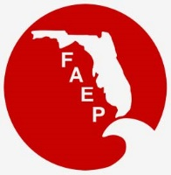 | FAEP CHAPTER MEETINGS  OCTOBER 2021
Chapter |  | Event | Speaker/Affiliation | Date and Time | Location | Contact
Central |  | Luncheon | Speaker: Bradley Friel, Greater Orlando Aviation Authority - Director of Planning  Topic:Orlando International Airport South Terminal Complex Construction. | Thursday, October 21st, 11:30 AM to 1:00 PM at the | Tap Room at Dubsdread,  549 Par Street Orlando, FL 32804. | Check for information at:  https://www.cfaep.org/
Northeast |  |  |  |  |  | Check for Events at  https://www.nefaep.org/  and the  NEFAEP Facebook Page
Northwest |  |  |  |  |  | Check for Events at  https://faep-nwfl.org/
South |  |  |  |  |  | Check for events at  https://www.sfaep.org/  and the  SFAEP Facebook Page!
Southwest |  | Spooky Networking Social |  | Saturday, October 16th |  | Check the SWFAEP Website for more details:  https://www.swfaep.org/
Southwest |  | Lunch and Learn | Topic: Red Tide  Speakers: Dr. Richard Pierce and Dr. Cindy Heil, Mote Marine Laboratory | Wednesday,  November 3rd  12-1:30pm | Online / Virtual | Register here!
Southwest |  | H2Whoa 5K Run for Water Research | Proceeds will go toward a scholarship opportunity for Florida Gulf Coast University students researching water quality. | Saturday,  November 6th | Lakes Park at  7330 Gladiolus Drive,  Fort Myers, FL 33908 | Register here!  Early Bird Discount  ends August 31st!
Tallahassee |  | Luncheon |  |  |  | Check  https://faep-tally.com/  for event details
Tampa Bay |  | Survival Skills | Preserved Path Florida  Survival School | October 9-10  October 23-24  (Women in STEM) | Sunnyhill Restoration Area in Umatilla, FL | Event Details and Registration
Tampa Bay |  | Virtual Luncheon | Speaker: Joshua Diamond, PhD, Cardno.  Topic: "Cavity Nest Webs of South Florida: Use of Elevated Video Inspection Systems, Verification of Citizen Science, and the Study of Nest Competition in an Invaded Urban Environment" | October 13th |  | Register Here!
Treasure Coast |  |  |  |  |  | Check  https://www.tcc-faep.org/  and the  TCC Facebook Page  for events!

Interested in reaching 1500 people for only $50 per month? Then sponsor the FAEP Calendar! Email info@faep-fl.org.

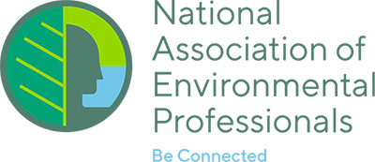
NAEP UPDATE

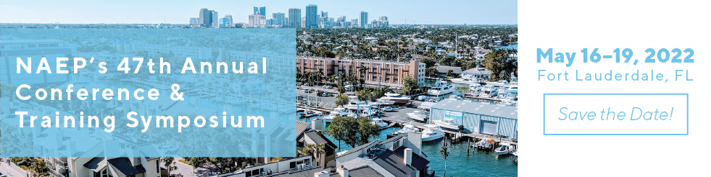

SUBMIT YOUR ABSTRACT FOR THE NAEP'S 47TH ANNUAL CONFERENCE & TRAINING SYMPOSIUM!
Submit your abstract to present at the NAEP Conference & Training Symposium in Fort Lauderdale, Florida, May 16–19, 2022, at the Westin Fort Lauderdale Beach. The NAEP 2022 Conference will be NAEP's first in-person event since 2019, so start dusting off your business cards! Stay tuned to emails from FAEP, the Beacon and NAEP.org for more information about the conference! Information on the conference is available here: https://naep.memberclicks.net/naep-2022-conference---training-symposium.

CALL FOR ARTICLES FOR THE ENVIRONMENTAL PRACTICE BULLETIN
The NAEP Environmental Practice Bulletin is published four times a year and emailed to all NAEP members. The newsletter is published in mid-February, May, August and November. Deadline for submissions is the end of the month prior to publication. NAEP is always looking for articles for this great practitioner-based publication. Consider providing NAEP’s nationwide audience a bit of your professional experience and insight. For more information about publishing in the Environmental Practice Bulletin visit: https://www.naep.org/publications.
NAEP PODCAST ENVIRONMENTAL PROFESSIONALS RADIO!
NAEP's Environmental Professional's Radio is bringing to you anything and everything related to being an environmental professional, including the following topics: NAEP Working Group info, career advice and insights, NEPA and other policy updates, Women in STEM, board member spotlights, updates from the NAEP President, and more! New episodes coming out weekly on Fridays! If you are interested in sponsoring, please visit the sponsor inquiry page. More information here: https://www.environmentalprofessionalsradio.com/

UPCOMING NAEP WEBINARS
Information on registering for upcoming NAEP webinars can be found at: https://www.naep.org/webinars-new. Past webinars are available here: https://naep.memberclicks.net/past-webinars. Here are the NAEP Webinars taking place in the upcoming months:
- October 27th - Environmental Rulemaking Update
- November 16th – Designing Resilient Transportation Infrastructure with GIS
NAEP NATIONAL DESK
Below is the link to the latest issues of the National Association of Environmental Professionals (NAEP) National Desk, which is provided to FAEP as a Chapter Affiliate Member benefit. The NAEP National Desk is a biweekly publication of current national issues affecting the environmental professional. provided through a licensing agreement with Environment and Energy (E&E) Publishing, LLC (www.eenews.net).
      - The September 24th issue can be found here.
- The September 10th issue can be found here.
Questions or comments on the NAEP National Desk should be directed to the NAEP at office@naep.org.

