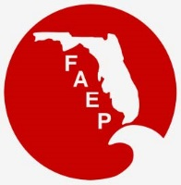 | FAEP CHAPTER MEETINGS  NOVEMBER 2019
Chapter |  | Event | Speaker/Affiliation | Date and Time | Location | Contact
Central |  | Holiday Event / Member Appreciation Event |  | Thurs, Nov 21  5:30 pm - 9:00 pm | Winter Park Farmer’s Market | https://www.cfaep.org/
Northeast |  | Luncheon | Todd Lindner, Cecil Airport | Wed, Nov 20  12:00 pm – 1:00 pm | Baymeadows Road Embassy Suites by Hilton | RSVP to  pgunsaulies@aellab.com
Northwest |  | No Event – Happy Holidays!
South |  | Wetland delineation training | Danielle Sattelberger, SFWMD | Nov 7 and 8  9:00 am – 5:00 pm | Doral, FL | https://www.eventbrite.com/e/sfaep-wetland-delineation-workshop-tickets-78476235533
South |  | Falliday Party / Annual Membership Meeting |  | Fri, Nov 15  7:00 – 9:00 pm | Hallandale Beach, FL | RSVP to rgoldman@broward.org
Southwest |  | Lunch & Learn: Endangered sawfish of Florida" |  | Wed, Nov 6 | Southwest Florida Community Foundation Collaboratory  Fort Myers | For more information: swfaep.org or membership@swfaep.org
Southwest |  | Lunch & Learn: Endangered sawfish of Florida" |  | Wed, Nov 13 | Colonial Oaks Park Sarasota | For more information: swfaep.org or membership@swfaep.org
Tallahassee |  | Luncheon: Pre-Legislative Session Update | Ryan Matthews, Hopping, Green and Sams, P.A.; and Kim Creamer, Governor’s Office | Wed, Nov 20  11:30 am – 1:00 pm | The Edison Restaurant  470 Suwannee St.  Tallahassee, FL 32301 | https://faep-tally.com/meetinginfo.php?id=8&ts=1573081711
Tampa Bay |  | Luncheon: Red Tide Panel – Local Impacts, Citizen Science, and Mitigation | Sean Tipton, Pinellas County;  Michelle Monteclaro, Pinellas County;  Grant Craig, Gulf of Mexico Coastal Ocean Observing System;  Cynthia Heil, PhD, Mote Marine Laboratory | Wed, Nov 20  11:30 am – 1:00 pm | Brio at International Mall  2223 N Westshore Blvd Tampa, FL 33607 | http://www.tbaep.org/events
Tampa Bay |  | Networking Social |  | Thurs, Nov 21  5:30 pm - 7:30 pm | Pin Chasers Bowling | http://www.tbaep.org/events
Treasure Coast |  | Night Hike and Marshmallow Roast |  | Wed, Nov 20  5:30 pm | Kitching Creek Pavilion at Jonathan Dickinson State Park | RSVP by Nov 18 to:  tcc.faep@gmail.com

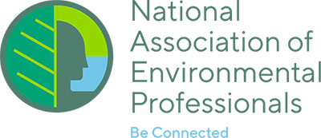
NAEP UPDATE

2020 NAEP Annual Conference and Training Symposium will be hosted by the FAEP/SFAEP in sunny Fort Lauderdale on May 18-22, 2020!

