Florida Beacon
From the President’s Desk  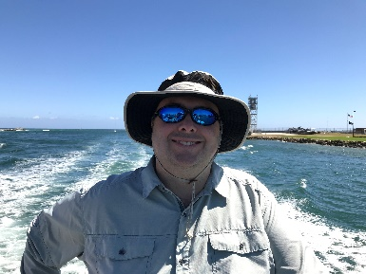  Ryan Goldman  Hello FAEP Members, | Florida Association of Environmental Professionals  Spring 2021  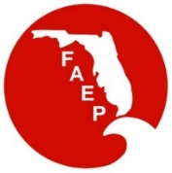
Welcome to Spring. Economic indicators forecast strong consumer sentiment and a busy second quarter for 2021. This is a positive note to our economy that has struggled over the past year due to the pandemic. As restrictions are slowly lifted and vaccines become more readily available, the economic outlook is strong moving forward with the desire to make up for any lost time over the past year. We hope that the economic recovery positively affects all of the diverse and varied environmental fields represented by our organization. We are all looking forward to a brighter 2021.  I am proud of the efforts of FAEP and the individual chapters as they have adapted and moved forward during the past year continuing to provide services and information to our members. The virtual meeting learning curve has for the most part passed as we become more accustomed to living room or beach scene backgrounds for our meetings. The FAEP has offered more content and virtual information during the pandemic than the previous year and most importantly, opened the chapter offerings to the statewide membership through this virtual format. The benefits of webinars and training opportunities from statewide chapters is a major improvement in connecting the state. This advancement and provides members a wider range of topics and fields of study than what was previously offered in their respective regions.  In marketing and national news, please be on the lookout for the upcoming article by the National Association of Environmental Professionals (NAEP), highlighting the efforts and accomplishments of the FAEP. This Chapter Spotlight focusses on and advertises the Florida Chapter’s strengths to the national audience. The publication should be out in the next few weeks. Thank you to all who contributed to its publication.  Finally, please be on the lookout for the FAEP 2021 Virtual Conference Call for Proposals and Sponsors. The Treasure Coast Chapter is hosting the 2021 virtual conference, which will take place this fall highlighting projects, legislative updates, case studies, and more. This conference would not be possible without the generous support of environmental industry and valued sponsors. Please consider submitting a presentation abstract or sponsorship opportunity. Presenters receive a discounted registration rate in appreciation for your participation. If you are interested in volunteering on the conference planning committee, please reach out to our board at any time.  Sincerely,  Ryan Goldman | FAEP Board of Directors
 | Ryan Goldman – President
 | Amy Guilfoyle – Past President
 | Elva Peppers – Vice Pres. & TL Chapter
 | Hannah Rowe – Treasurer
 | John Abbott – Secretary & SO Chapter
 | Bruce Hasbrouck - Parliamentarian
 | Joshua Hirten – CN Chapter
 | David Wood – NE Chapter
 | Will Stokes - NW Chapter
 | Jen Savaro – SO Chapter
 | Emma Fain – SW Chapter
 | Scott Graf – TB Chapter
 | Gina Chiello – TC Chapter
 | George Sprehn – At Large Member
 | Joe Penta – At Large Member
 | Jill King – At Large Member
 | Tim Perry – At Large & NAEP Rep.
 | Check the last page of our newsletter to determine if you qualify for a discount on your FAEP membership!
Find out more about FAEP
Member’s Benefits at our website: WWW.FAEP-FL.ORG

NAEP Update
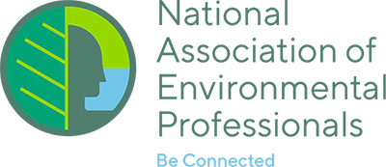
THE 2021 NAEP CONFERENCE AND TRAINING SYMPOSIUM GOES VIRTUAL!
Save the Date for the 2021 NAEP Virtual Conference and Training Symposium co-hosted by NAEP and the Transportation Research Board May 16-20, 2021. NAEP is currently preparing the program which includes oral presentations, posters, workshops, and special sessions of national concern.
Stay tuned to the NAEP website as sponsorship and virtual exhibitor opportunities
will be coming soon!
CALL FOR ARTICLES FOR THE ENVIRONMENTAL PRACTICE BULLETIN
The NAEP Environmental Practice Bulletin is published four times a year and emailed to all NAEP members. The newsletter is published in mid-February, May, August and November. Deadline for submissions is the end of the month prior to publication. NAEP is always looking for articles for this great practitioner-based publication. Consider providing NAEP’s nationwide audience a bit of your professional experience and insight. For more information about publishing in the Environmental Practice Bulletin visit: https://www.naep.org/publications.
Tampa Bay Chapter Annual Photo Contest!
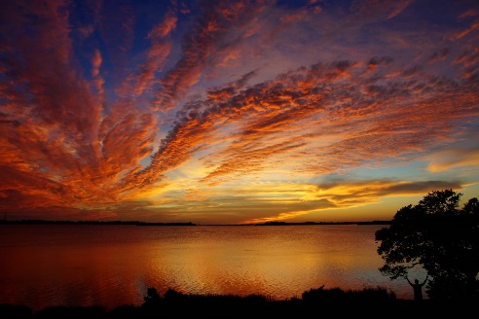
The Tampa Bay Chapter held its annual photo contest recently, and, as usual, the photos were extremely high-caliber and very competitive.
Sky's On Fire

The First-place winner is a Tampa Bay sunset photo taken by Peter A. Clark titled Sky’s on Fire.
Burrowing Owl Family

Second place is by Bryan Manley and is titled Burrowing Owl Family.

Box Turtle Shelter

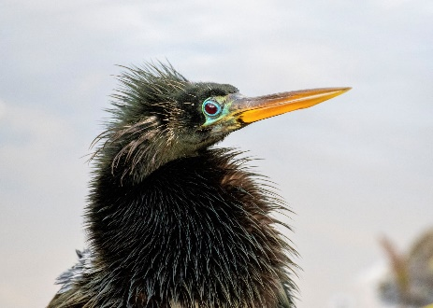
Third place is Box Turtle Shelter by Denise Ward.
Covid Hair Don't Care

The Fan Favorite is Covid Hair Don’t Care by Nanette O’Hara.
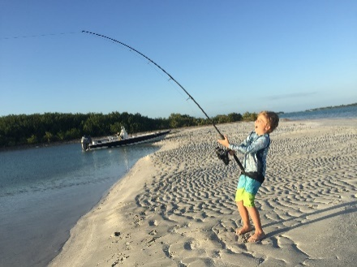
Fish On!

Thank you to all of the photo contributors! The contest was improved by photos that reflect some of the activities our members participated in during the 2020 social distancing environment created by the pandemic (see Fish On! By Bryan Anderson).

We also noticed photos of increased outside activity from our members this year!
Florida Beacon
Published Quarterly by the Florida Association of Environmental Professionals
2

SFAEP Webinar on
UAS for Improved Coastal Wetland Monitoring and Restoration
In February, SFAEP hosted a virtual webinar on Unmanned Aircraft Systems (UAS) for improved coastal wetland monitoring and restoration. The webinar was presented by Sara Durgan, Ph.D., a remote sensing and UAS Data Scientist with AECOM.
Sara first provided an overview of UAS survey hardware and software requirements, including different types of drones and cameras, and explained the need for ground control points for accurate georeferencing and the need for calibration targets to account for atmospheric lighting conditions and other variables. She explained the basics of photogrammetry, and the differences between multispectral and hyperspectral remote sensing.
Sara summarized two case studies that were part of her dissertation. Both studies focused on restored wetlands in Biscayne Bay.
The first study was designed to determine the impact of flight plan (flight altitude, image overlap, lighting conditions, and sensor characteristics) on the photogrammetric data quality. The key conclusion was that flight configuration has a significant impact on photogrammetric data quality. In particular, lower elevations produced more accurate terrain models (as would be expected) but higher elevations produced smoother and more accurate canopy height data. Also, increasing image overlap from 80% to 90% increased data quality due to increased viewing angles over the vegetated area.
The second case study was using UAS for wetland species mapping. Using machine learning algorithms, the UAS was able to identify species with approximately 70% accuracy for a relatively ecologically diverse site with 17 predominant species, and approximately 93% accuracy for a less diverse site with 8 predominant species.
Despite some clear advantages of using UAS in such applications, several constraints remain including lack of precision in some data and regulatory barriers.
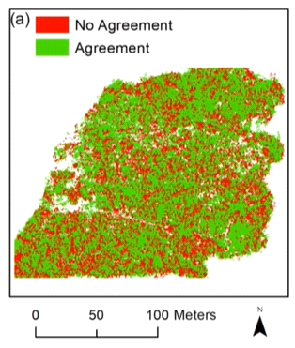
Florida Beacon
Published Quarterly by the Florida Association of Environmental Professionals
3

The Florida-Friendly Landscaping Program Overview
The Florida-Friendly Landscaping program is a science-based educational program and a partnership between the Florida Department of Environmental Protection and the University of Florida IFAS Extension. The goal of the program is to work with homeowners and professionals to design and maintain landscapes that will thrive in Florida’s climate. With approximately 60% of homeowner water use in Florida going to lawn and landscape irrigation, that is the best place to focus conservation efforts. The program is guided by nine principles. In this article we will give you a brief overview of the nine principles, some tips for each principal and explore how Florida friendly is worded in the state codes.
Principles & TIPS
- Right Plant, Right Place: Consider sun, water and soil pH
- Water Efficiently: Apply no more than ½-3/4 of an inch per application
- Fertilize Appropriately: Follow local ordinances and select a Slow Release Nitrogen product.
- Mulch: Choose a sustainable mulch like pine needles over Cypress tree mulch or rocks.
- Attract Wildlife: Plant flowering perennials
- Manage Yard Pests Responsibly: No routine pesticide spraying, try to identify insects because they might be beneficial.
- Recycle Yard (and kitchen) Waste: Use your leaves as mulch, compost kitchen and yard waste or leave grass clipping on the lawn so they can return nutrient back to the soil.
- Reduce Stormwater Runoff: Vegetate stormwater ponds; collectively they make up a lot of green space for our wildlife.
- Protect the Waterfront: Leave a low maintenance zone of at least 10 feet where no fertilizer or pesticides are used and native species are allowed to grow.
Florida-Friendly Landscaping in the Florida State Statutes: Highlights of Fl State Statute Chapter 373.185
The Florida Legislature finds that the use of Florida-Friendly Landscaping™ serves a compelling public interest and that the participation of homeowners’ associations is essential to the state’s efforts in water conservation and water quality protection and restoration.
In fact, Florida Statute 373.185 defines a Florida-Friendly landscape as “quality landscapes that conserve water, protect the environment, are adaptable to local conditions, and are drought tolerant”. In addition, the statute states a deed restriction, covenant, or local government ordinance may not prohibit or be enforced so as to prohibit any property owner from implementing Florida-friendly landscaping on his or her land. It also prohibits any watering mandates that violate water management district water use restrictions.
The statute, however, does not invalidate HOA architectural control and landscape committee decisions. Homeowners can implement FFL as long as they comply with code restrictions and gain approval from the appropriate committee. Homeowner associations may require certain elements of Florida-Friendly Landscaping™ to be located to the back, or side yard.
By Tina McIntyre, Florida-Friendly Landscaping Agent at the UF/IFAS Extension in Seminole County and Claire Lewis, Florida-Friendly Communities Statewide Coordinator
Florida Beacon
Published Quarterly by the Florida Association of Environmental Professionals
4
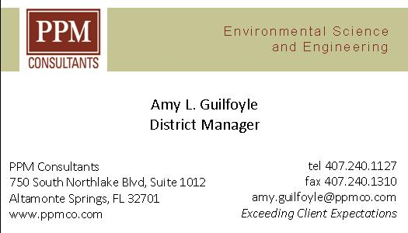
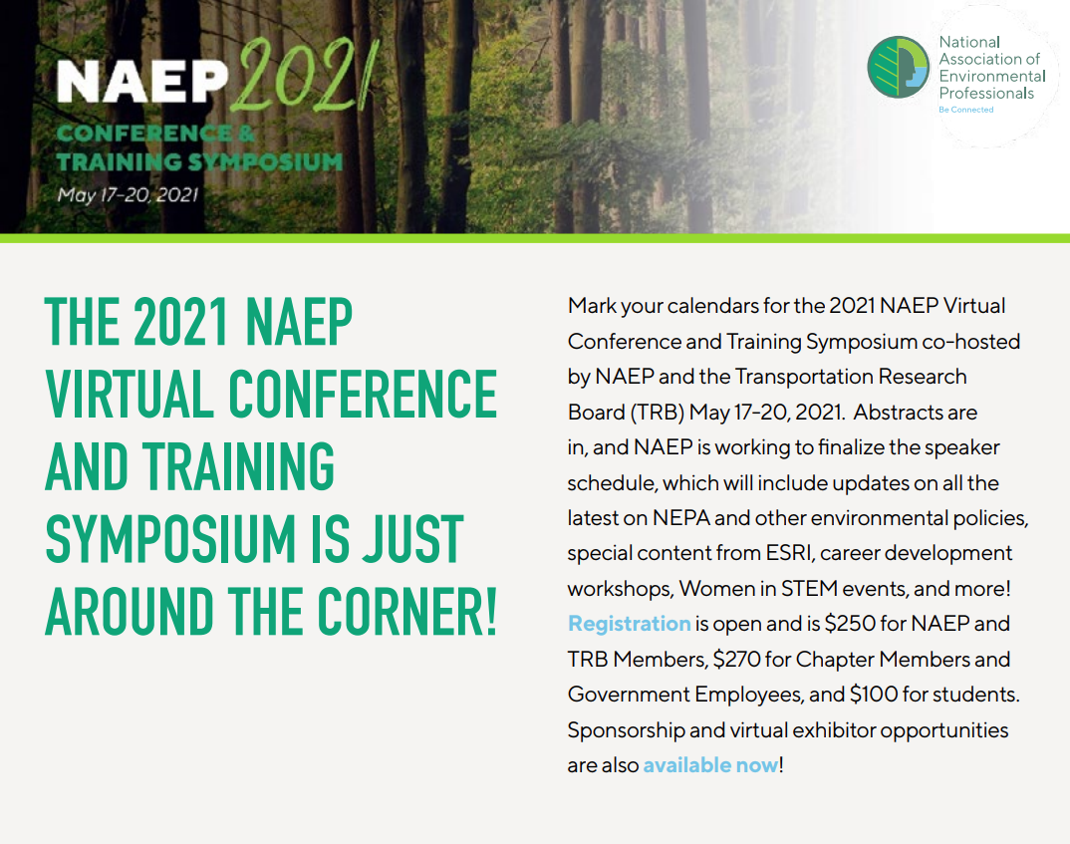
The Academy of Board Certified Professionals (ABCEP) is the certifying body for NAEP and the lead organization certifying environmental professionals; maintaining exemplary standards of ethics and technical practice; and supporting individuals, our profession, and the public relying upon our services. It is a board-certified recognition.
Beyond the acknowledgement by your peers, earning and maintaining the Certified Environmental Professional (CEP) designation is beneficial as a key differentiator when bidding on projects. It also opens new doors personally and professionally.
ABCEP would like to enhance the CEP (and CEP-IT) by growing our numbers and raising the awareness and value of the credential. If interested, you can find more details about the CEP and the application process on our website https://www.abcep.org. If you email the office (office@abcep.org), our Administrator will follow up to see if you have additional questions about the application process, and offer to assign a mentor to help guide you through it.
The initial CEP application fee is typically $200. ABCEP is offering a 10% discount through the end of 2020 reducing the initial CEP application fee to $180. This is a great time to submit your application! We also have a CEP-IT application for those that don’t quite meet the CEP requirements.
Making the decision to pursue a certification can feel like a daunting task, but in this climate, having the designation after your name can prove that crucial differentiator. Please share this with anyone in your office that might be interested.
6

Texas Blackouts Point to Coast-to-Coast Crises Waiting to Happen
Continent-spanning storms triggered blackouts in Oklahoma and Mississippi,
halted one-third of U.S. oil production and disrupted vaccinations in 20 states.
Even as Texas struggled to restore electricity and water recently, signs of the risks posed by increasingly extreme weather to America’s aging infrastructure were cropping up across the Country. The continent-spanning winter storms triggered blackouts in Texas, Oklahoma, Mississippi and several other states. One-third of oil production in the nation was halted. Drinking-water systems in Ohio were knocked offline. Road networks nationwide were paralyzed and vaccination efforts in 20 states were disrupted.
The crisis carries a profound warning. As climate change brings more frequent and intense storms, floods, heat waves, wildfires and other extreme events, it is placing growing stress on the foundations of the country’s economy: Its network of roads and railways, drinking-water systems, power plants, electrical grids, industrial waste sites and even homes. Failures in just one sector can set off a domino effect of breakdowns in hard-to-predict ways.
Much of this Infrastructure was built decades ago, under the expectation that the environment around it would remain stable, or at least fluctuate within predictable bounds. Now climate change is upending that assumption.
“We are colliding with a future of extremes,” said Alice Hill who oversaw planning for climate risks on the National Security Council during the Obama administration. “We base all our choices about risk management on what’s occurred in the past, and that is no longer a safe guide.”
While it’s not always possible to say precisely how global warning influenced any one particular storm, scientists said, an overall rise in extreme weather creates sweeping new risks.
A broken water main in McComb, Mississippi
Sewer systems are overflowing more often as powerful rainstorms exceed their design capacity. Coastal homes and highways are collapsing as intensified runoff erodes cliffs. Coal ash, the toxic residue produced by coal-burning plants, is spilling into rivers as floods overwhelm barriers meant to hold it back. Homes once beyond the reach of wildfires are burning blazes they were never designed to withstand.
Problems like these oft6en reflect an inclination of governments to spend as little money as possible, said Shalini Vajjhala, a former Obama administration official who now advises cities on meeting climate threats. She said it’s hard to persuade taxpayers to spend extra money to guard against disasters that seem unlikely.
But climate change flips that logic, making inaction far costlier. ”The argument I would make is, we can’t afford not to, because we’re absorbing the costs” later, Ms. Vajjhala said, after disasters strike. “We’re spending poorly.”
The Biden administration has talked extensively about climate change, particularly the need to reduce greenhouse gas emissions and create jobs in renewable energy. But it has spent less time discussing how to manage growing effects of climate change, facing criticism from experts for not appointing more people who focus on climate resilience.
A White House spokesman, Verdant Patelo, said in a statement, “Building resilient and sustainable infrastructure that can withstand extreme weather and changing climate will play an integral role in creating millions of good paying, union jobs” while cutting greenhouse gas emissions.
And while President Biden has called for a major push to refurbish and upgrade the nation’s infrastructure, getting a closely divided Congress to spend hundreds of billions, if not trillions of dollars, will be a major challenge.
Continued here…. From the New York Times Climate Forward
Florida Beacon
Published Quarterly by the Florida Association of Environmental Professionals
7
Biden Details $2 Trillion Plan to
Rebuild Infrastructure and Reshape the Economy
The President began selling his proposal, saying it would fix 20,000 miles of roads and 10,000 Bridges, while also addressing climate change and racial inequities and raising corporate taxes.
WASHINGTON — President Biden introduced a $2 trillion plan last week to overhaul and upgrade the nation’s infrastructure, calling it a transformational effort that could create the “most resilient, innovative economy in the world.”
“It is not a plan that tinkers around the edges,” Mr. Biden said in a speech outside Pittsburgh. “It is a once-in-a-generation investment in America.”
White House officials said the proposal’s combination of spending and tax credits would translate into 20,000 miles of rebuilt roads, repairs to the 10 most economically important bridges in the country, the elimination of lead pipes from the nation’s water supplies and a long list of other projects intended to create millions of jobs in the short run and strengthen American competitiveness in the long run.
They said the plan would also accelerate the fight against climate change by hastening the shift to new, cleaner energy sources, and would help promote racial equality in the economy.
The provisions would improve wages, internet service, drinking water and commute times, Mr. Biden said.
The costs would be offset by increased corporate tax revenues raised over 15 years, particularly from multinationals that earn and book profits overseas. The president cast those increases as a means to prod companies into investing and producing more in the United States.
With Republicans already signaling skepticism or outright opposition, Mr. Biden appealed for support from both parties in Congress, saying the program would be “unlike anything we have seen or done since we built the interstate highway system and the space race decades ago” and calling it “the largest American jobs investment since World War II.”
The spending in the plan would take place over eight years, the president said, and the tax increases would more than offset that spending in 15 years, leading to an eventual reduction of the budget deficit. Unlike the economic stimulus passed under President Barack Obama in 2009, when Mr. Biden was vice president, officials will not in every case prioritize so-called shovel-ready projects that could quickly bolster growth.
But even spread over years, the scale of the proposal underscores how fully Mr. Biden has embraced the opportunity to use federal spending to address longstanding social and economic challenges in a way not seen in a half-century.
Officials said that, if approved, the spending in the plan would end decades of stagnation in federal investment in research and infrastructure — and would return government investment in those areas, as a share of the economy, to its highest levels since the 1960s.
The proposal is the first half of what will be a two-step release of the president’s ambitious agenda to overhaul the economy and remake American capitalism, which could carry a total cost of as much as $4 trillion over a decade. Mr. Biden’s administration has named it the “American Jobs Plan,” echoing the $1.9 trillion pandemic relief bill that Mr. Biden signed into law this month, the “American Rescue Plan.”
On Wednesday, Mr. Biden said the next phase, which he will seek to pay for in part through tax increases on wealthy individuals, would come in a matter of weeks and be known as the “American Family Plan.”
While spending on roads, bridges and other physical improvements to the nation’s economic foundations has always had bipartisan appeal, the plan Mr. Biden rolled out on Wednesday drew quick opposition from the right for its size and its reliance on corporate tax increases.
Click here for more… From The New York Times Climate and the Environment
Florida Beacon
Published Quarterly by the Florida Association of Environmental Professionals
8

Florida Crisis Highlights a Nationwide Risk from Toxic Ponds
Thousands of open-air waste ponds near power plants, mines and industrial farms can pose safety dangers from poor management and, increasingly, the effects of climate change.
They are ponds the size of city blocks: Wastewater pits that hold the hazardous byproducts of coal. Lagoons brimming with diluted pig excrement. Vast pools atop stacks of radioactive tailings. The risks posed by pools of waste like these, a common feature at thousands of industrial and agricultural sites across the country, have been brought into sharp relief by a giant wastewater pond in Piney Point, Fla., that in recent days had appeared in danger of catastrophic failure.
Officials on Monday said the threat of collapse had passed and residents were allowed to return home after an emergency effort had pumped millions of gallons of water out of the pond and into local waterways. The environmental effects of such a large release of contaminated water remained unknown. This past weekend, the specter of a deluge had prompted the authorities to evacuate hundreds of people from their homes.
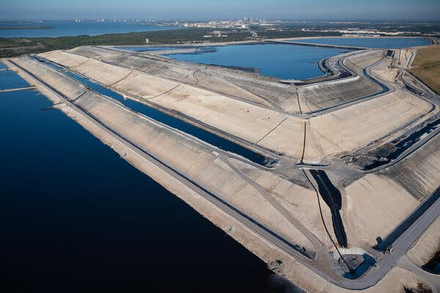
Open-air ponds are vital to major industries, like livestock and power generation. But environmental groups say they pose major environmental, health and safety risks, whether from mismanagement, or, increasingly, from the effects of climate change.
A pond, built atop a mound of waste from phosphorous mining, in Riverview, FL
“They’re just an irresponsible way to store very dangerous waste,” said Daniel Estrin, general counsel at the Waterkeeper Alliance, a clean water nonprofit group. “And with climate change, we’re going to see more frequent and stronger storms that are going to impact these sites.”
The Florida emergency, at a former phosphate mining plant south of Tampa, is particularly dire. There, a pool that initially held more than 400 million gallons of wastewater, with traces of heavy metals and other toxic substances, sits atop a pile of phosphogypsum tailings at least 70 feet tall. Tailings are waste that is left behind when ores from phosphate mining are processed to create phosphoric acid, an ingredient used in fertilizer. For decades, the tailings, a radioactive wet slurry containing traces of radium along with arsenic, lead, and other elements, were placed in ponds and left to evaporate, leaving behind enormous stacks of phosphogypsum topped by water.
Read more here… From The New York Times
Science Shorts ~NPR Short Wave ~ The Science Behind the Headlines
Are seasonal allergies getting worse? | NPR asks allergy expert Dr. Juanita Mora if seasonal allergies are getting worse. Plus, some quick tips for managing those pesky allergy symptoms.
Fulgurite: What a lightning-formed rock may have contributed to life on Earth | When lightning strikes the ground, it can leave behind a root-like rock called a fulgurite. Host Maddie Sofia talks with NPR science correspondent Nell Greenfieldboyce about what lightning and its funky rock creation can reveal about the origins of life.
What we can learn from microscopic life in Antarctica | NPR colleagues at the TED Radio Hour introduce us to wildlife filmmaker Ariel Waldman. She says the coldest continent is brimming with invisible life that can only be seen through microscopes, including tardigrades.
Florida Beacon
Published Quarterly by the Florida Association of Environmental Professionals
9

FAEP Group Discount Memberships
Did you know that FAEP provides a discount on our membership to employers who have 5 or more members? If your company or organization qualifies for the Group Membership you save $5 on each FAEP new member or renewing member, lowering the FAEP membership fee from $40 to $35 for everyone from your company or organization. If your company or organization is on this list, you are eligible to join or renew at the discounted Group rate. Some of our member organizations renew all of their employee-members at the same time with a single payment. The FAEP Board would like to extend a thank you to the following employers for supporting their employee’s professional development and the FAEP mission:
AECOM |  | Cummins Cederberg |  |  | GeoSyntec Consultants |  | Orange County EPD
Atkins |  | DRMP, Inc. |  |  | HSW Engineering |  | Terracon
Bio-tech Consulting, Inc. |  | Earth Sciences, Inc. |  |  | Jacobs Engineering |  | TetraTech, Inc.
Broward County |  | EarthBalance |  |  | Johnson Engineering Inc. |  | Turrell, Hall & Associates
Cardno |  | Flatwoods Consulting Group |  |  | Mosaic |  | USF
Clark Environmental |  | Florida Water Management Districts |  |  | MSE Group |  | WGI
 |  | FDEP
Interested in advertising to almost 2000 Environmental Professionals in the FAEP’s newsletter and on our website?  One year sponsorships also get your  organization logo on our webpage!  Sponsorship Rates |  |  |  |  |  | Florida Beacon  Published Quarterly by the  Florida Association of Environmental Professionals  Teri Hasbrouck, Editor  PO Box 7416  St. Petersburg, FL 33734  Email: info@faep-fl.org  If you would like to submit an article to the Beacon contact the editor at info@faep-fl.org.
Size | One Issue |  | One Year Plus Logo on Website
Biz Card | $35 |  | $100
¼ Page | $100 |  | $375
½ Page | $175 |  | $650
1 Page | $250 |  | $900
Florida Beacon
Published Quarterly by the Florida Association of Environmental Professionals
 |  |  |  | 10

