Florida Beacon
From the President’s Desk  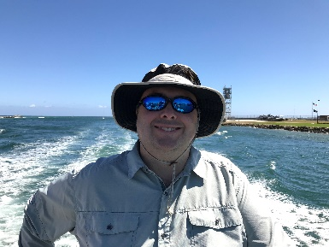  Ryan Goldman  Dear FAEP Members, |  | Florida Association of Environmental Professionals  Fall 2020  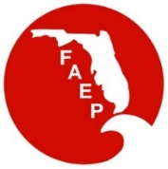
Happy Fall, I hope that everyone had a safe summer as we co-exist with COVID. The changes in our daily lives are becoming more routine as we develop new skills at work and at home. As our collective familiarity with video platforms increases, there has also been an increase in participation and presentations broadcast to our members. We hope to see that trend continue with the broadening of FAEP event marketing and offerings. While many of the events have changed in venue, the chapters continue to provide informative and quality member benefits on a regular basis. The FAEP has offered to advertise any individual chapter events to the entire state membership at the request of the chapter to widen the appeal and increase the diversity of events. Please consider extending your audience and increasing participation to all eight chapters.  Not only are there events to appeal to our wide audience of disciplines, but the varied formats include all forms of social media and video platforms. Please refer to the monthly calendar for statewide events in addition to your individual chapter offerings for something to educate and entertain. Recent offerings have included webinars, scholarships, contests with cash prizes, and photo contests.  As we cautiously wait for a time when unrestricted in-person gatherings will become normal, some events are returning to in-person meetings while adhering to all regulatory health guidelines. Outdoor guided tours and networking socials are some of the recommended ways to enjoy the fall weather.  For planning purposes, I would like to share a recent decision to schedule the annual FAEP 2021 conference for the Fall of 2021, exact time and dates TBD. Moving the statewide conference from the Spring to the fall allows for more planning and hopefully the option to host in person events with the customary sponsor booths and field trips. Many attendees and sponsors have expressed the desire for the in-person meeting format and if we have the chance to provide that type of event, we will work toward that goal for all parties involved.  Thank you,  Ryan Goldman  FAEP President |  | FAEP 2020 Board of Directors
 |  | Ryan Goldman – President
 |  | Amy Guilfoyle – Past President
 |  | Elva Peppers – Vice Pres. & TL Chapter
 |  | Hannah Rowe – Treasurer
 |  | John Abbott – Secretary & SO Chapter
 |  | Bruce Hasbrouck - Parliamentarian
 |  | Joshua Hirten – CN Chapter
 |  | David Wood – NE Chapter
 |  | Will Stokes - NW Chapter
 |  | Emma Fain – SW Chapter
 |  | Scott Graf – TB Chapter
 |  | Gina Chiello – TC Chapter
 |  | George Sprehn – At Large Member
 |  | Joe Penta – At Large Member
 |  | Jill King – At Large Member
 |  | Tim Perry – At Large & NAEP Rep.
 |  | Check the last page of our newsletter to determine if you qualify for a discount on your FAEP membership!
Next FAEP Board Meeting!!
The next FAEP Board of Directors Meeting
is November 23, 2020 at 12:00
(contact info@faep-fl.org for meeting logon information)
Find out more about FAEP
Member’s Benefits at our website: WWW.FAEP-FL.ORG
Thank you SFAEP!!
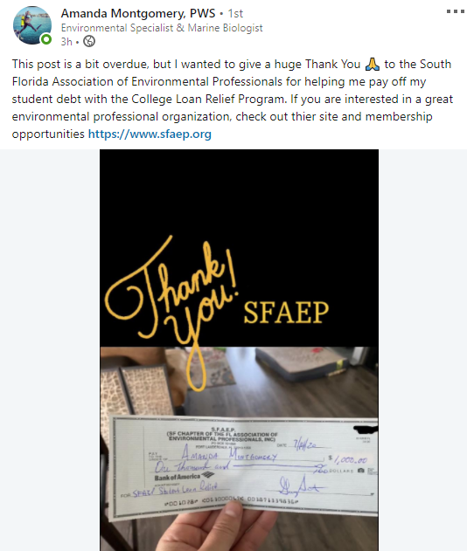
Florida Beacon
Published Quarterly by the Florida Association of Environmental Professionals
2
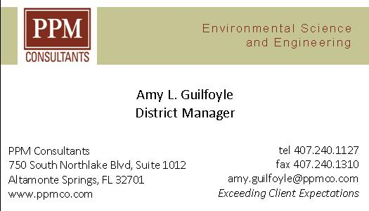
Floodgates in Venice Work in First Major Test
The fiercely contested floodgate system was used to recently stop a high tide from flooding Venice’s fragile streets. The system held, but will it work as the climate worsens?
After decades of bureaucratic delays, corruption and resistance from environmental groups, sea walls designed to defend Venice from “acqua alta,” or high water, went up on October 3rd, testing their ability to battle the city’s increasingly menacing floods.
By 10 a.m., all 78 floodgates barricading three inlets to the Venetian lagoon had been raised, and even when the tide reached as high as four feet, water levels inside the lagoon remained steady, officials said.
“There wasn’t even a puddle in St. Mark’s Square,” said Alvise Papa, the director of the Venice department that monitors high tides.
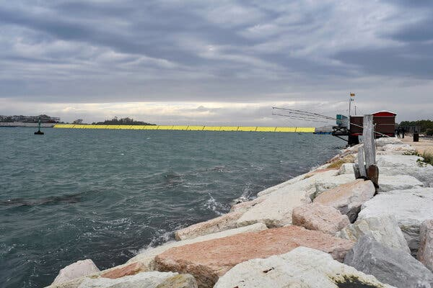
Had the flood barriers not been raised, about half the city’s streets would have been under water, and visitors to St. Mark’s Square — which floods when the tide nears three feet — would have been wading in a foot and a half of water, he said.
“Everything dry here. Pride and joy,” tweeted Luigi Brugnaro, Venice’s newly re-elected mayor.
Designed some four decades ago to help save Venice from flooding, the mobile barrier system was delayed by cost overruns, corruption, and opposition from environmental and conservation groups. The cost of the system tripled from initial estimates, and a 2014 bribery scandal led to the arrest of the then-mayor, Giorgio Orsoni, and dozens of others, including politicians and businessmen involved in the project. Mr. Orsoni and some of the others charged were acquitted.
“We found a difficult situation and slowly, slowly we’ve been able to resolve things,” said Giuseppe Fiengo, one of the commissioners who have overseen the project since 2014. “The important thing is that today, for the first time, with high water, Venice didn’t flood.” The floodgates have been tested several times over the past summer, but under less threatening weather conditions than those on Saturday. “This time we raised them to defend Venice,” said Alberto Scotti, the engineer who designed them.
The system is not fully operational yet. Some infrastructure still needs to be completed, and workers haven’t been fully trained, so Saturday’s operation was technically a test. “But it’s a test that had an objective, to guarantee the safety of the city, and it did,” Mr. Scotti said.
The construction firms building the system have until December 2021 to finish the work. When it is fully operational, the floodgates will be activated whenever the tide reaches 3½ feet. Until then, the floodgates will be operated when the tide reaches four feet, as it did on Saturday. Though significant, Saturday’s tide levels were a far cry from the exceptionally high water levels seen last year — six feet — and the year before, endangering the city and prompting the mayor to declare a state of emergency. Mr. Scotti said the floodgates had been designed to defend the city “even in anomalous situations,” and even with high tides reaching nearly 10 feet.
While supporters of the project welcomed Saturday’s test as a major victory, some pointed out that the floodgates won’t fully solve the growing threat posed by climate change. Increasing sea levels and new wind patterns could force the floodgates to stay up so often that it could destroy ship traffic or turn the Venice lagoon into a swamp.
“With climate change, there’s a chance that the floodgates could be employed 150-180 days a year, becoming an almost fixed barrier and severing the lagoon’s relation to the sea,” said Cristiano Gasparetto, an architect and former provincial official who has long opposed the project. “If the lagoon is cut off from the sea for long periods, it dies, because the natural exchange of waters stops, and all of its organic life risks decaying,” he said. “If the lagoon dies, Venice dies,” he added. “It loses its characteristics.”
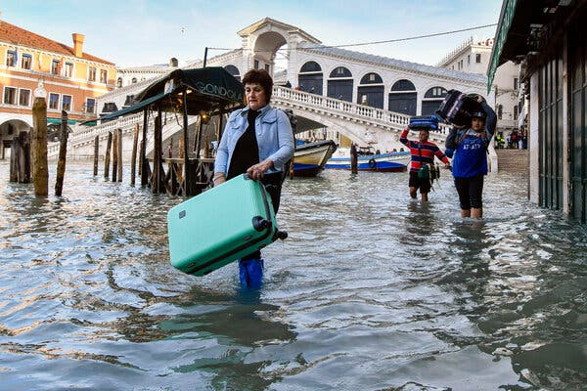
Mr. Gasparetto also said he doubted that the floodgates would work in extreme conditions with high waves and strong winds. “There is still a lot of uncertainty,” he said. “Today’s test says nothing when it comes to that.” Concerns also remain about the costs of maintaining the floodgates and potential damage from saltwater.
Still, the operation of the gates on Saturday was greeted in Venice as progress.
“Today we had the certainty that it works,” Luca Zaia, the president of the Veneto region, which includes Venice, told reporters on Saturday. “At least we know that it can help Venice.”
From The New York Times Climate Forward Newsletter
The Academy of Board Certified Professionals (ABCEP) is the certifying body for NAEP and the lead organization certifying environmental professionals; maintaining exemplary standards of ethics and technical practice; and supporting individuals, our profession, and the public relying upon our services. It is a board-certified recognition.

Beyond the acknowledgement by your peers, earning and maintaining the Certified Environmental Professional (CEP) designation is beneficial as a key differentiator when bidding on projects. It also opens new doors personally and professionally.

ABCEP would like to enhance the CEP (and CEP-IT) by growing our numbers and raising the awareness and value of the credential. If interested, you can find more details about the CEP and the application process on our website https://www.abcep.org. If you email the office (office@abcep.org), our Administrator will follow up to see if you have additional questions about the application process, and offer to assign a mentor to help guide you through it.

The initial CEP application fee is typically $200. ABCEP is offering a 10% discount through the end of 2020 reducing the initial CEP application fee to $180. This is a great time to submit your application! We also have a CEP-IT application for those that don’t quite meet the CEP requirements.

Making the decision to pursue a certification can feel like a daunting task, but in this climate, having the designation after your name can prove that crucial differentiator. Please share this with anyone in your office that might be interested.
Florida Beacon
Published Quarterly by the Florida Association of Environmental Professionals
5

The World’s Largest Tropical Wetland Has Become an Inferno
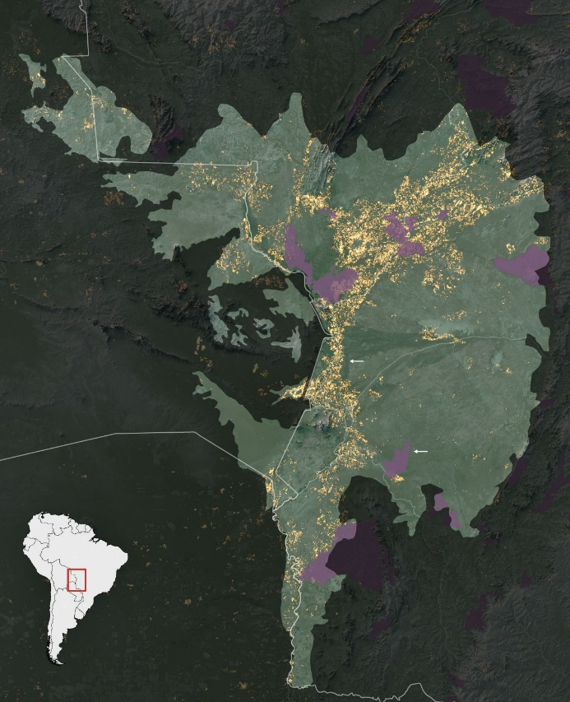
This year, roughly a quarter of the vast Pantanal wetland in Brazil, one of the most biodiverse places on Earth, has burned in wildfires worsened by climate change. What happens to a rich and unique biome when so much is destroyed?
The unprecedented fires in the wetland have attracted less attention than blazes in Australia, the Western United States and the Amazon, its celebrity sibling to the north. But while the Pantanal is not a global household name, tourists in the know flock there because it is home to exceptionally high concentrations of breathtaking wildlife: Jaguars, tapirs, endangered giant otters and bright blue hyacinth macaws. Like a vast tub, the wetland swells with water during the rainy season and empties out during the dry months. Fittingly, this rhythm has a name that evokes a beating heart: the flood pulse.
The wetland, which is larger than Greece and stretches over parts of Brazil, Paraguay and Bolivia, also offers unseen gifts to a vast swath of South America by regulating the water cycle upon which life depends. Its countless swamps, lagoons and tributaries purify water and help prevent floods and droughts. They also store untold amounts of carbon, helping to stabilize the climate.
For centuries, ranchers have used fire to clear fields and new land. But this year, drought worsened by climate change turned the wetlands into a tinderbox and the fires raged out of control.
“The extent of fires is staggering,” said Douglas C. Morton, who leads the Biospheric Sciences Laboratory at the NASA Goddard Space Flight Center and studies fire and food production in South America. “When you wipe out a quarter of a biome, you create all kinds of unprecedented circumstances.”
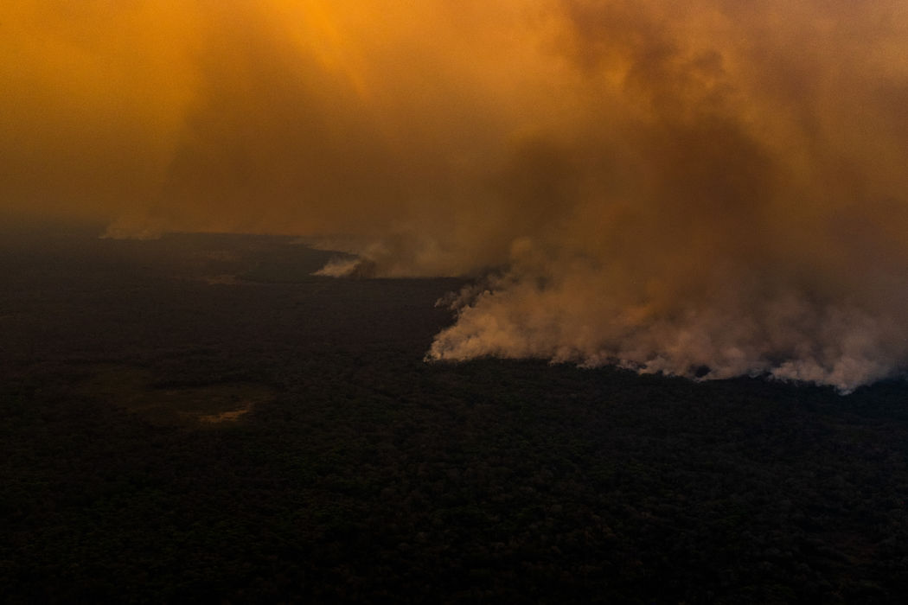
His analysis showed that at least 22 percent of the Pantanal in Brazil has burned since January, with the worst fires, in August and September, blazing for two months straight.
Naturally occurring fire plays a role in the Pantanal, in addition to the burning by ranchers. The flames are usually contained by the landscape’s mosaic of water. But this year’s drought sucked these natural barriers dry. The fires are far worse than any since satellite records began.
The fires are also worse than any in the memory of the Guató people, an Indigenous group whose ancestors have lived in the Pantanal for thousands of years.
Guató leaders in an Indigenous territory called Baía dos Guató said the fires spread from the ranches that surround their land, and satellite images confirm that the flames swept in from the outside. When fire started closing in on the home of Sandra Guató Silva, a community leader and healer, she fought to save it with the help of her son, grandson and a boat captain with a hose. Click here for an interactive map and more information.
For many desperate hours, she said, they threw buckets of river water and sprayed the area around the house and its roof of thatched palm leaves. They succeeded in defending it, but at least 85 percent of her people’s territory burned, according to Instituto Centro de Vida, a nonprofit group that monitors land use in the area. Throughout the Pantanal, almost half of the Indigenous lands burned, an investigative journalism organization called Agência Pública found.
Now Ms. Guató Silva mourns the loss of nature itself. “It makes me sick,” she said. “The birds don’t sing anymore. I no longer hear the song of the Chaco chachalaca bird. Even the jaguar that once scared me is suffering. That hurts me. I suffer from depression because of this. Now there is a hollow silence. I feel as though our freedom has left us, has been taken from us with the nature that we have always protected.”
Now these people of the wetlands, some still coughing after weeks of smoke, are depending on donations of water and food. They fear that once the rains come in October, ash will run into the rivers and kill the fish they rely on for their food and livelihood.
“I couldn’t help but think, our Pantanal is dead,” said Eunice Morais de Amorim, another member of the community. “It is so terrible.”
Scientists are scrambling to determine an estimate of animals killed in the fires. While large mammals and birds have suffered casualties, many were able to run or fly away. It appears that reptiles, amphibians and small mammals have fared the worst. In places like California, small animals often take refuge underground during wildfires. But in the Pantanal, scientists say, fires burn underground too, fueled by dried-out wetland vegetation. One of the hard-hit places was a national park designated as a United Nations World Heritage site.
“I don’t want to be an alarmist,” said José Sabino, a biologist at the Anhanguera-Uniderp University in Brazil who studies the Pantanal, “but in a region where 25 percent has burned, there is a huge loss.”
As the worst flames raged in August and September, biologists, ecotourism guides and other volunteers turned into firefighters, sometimes working 24 hours at a time. Fernando Tortato, a conservation scientist with Panthera, a group that advocates for big cats, visited the Pantanal in early August to install cameras for his research monitoring jaguars and ocelots. But he found the camera sites burned.
“I said to my boss, I need to change my job,” Mr. Tortato said. “I need to be a firefighter.” Instead of returning home to his family, he spent much of the next two months digging fire breaks with a bulldozer in an urgent attempt to protect forested areas.
One day in September, working under an orange sky, he and his team finished a huge semicircular fire break, using a wide river along one side to protect more than 3,000 hectares, he said, a vital refuge for wildlife. But as the men stood there, pleased with their accomplishment, they watched as flaming debris suddenly jumped the river, igniting the area they thought was safe. They raced into boats and tried to douse the spread, but the flames quickly climbed too high.
“That’s the moment that we lost hope, almost,” Mr. Tortato said. “But the next day we woke up and started again.”
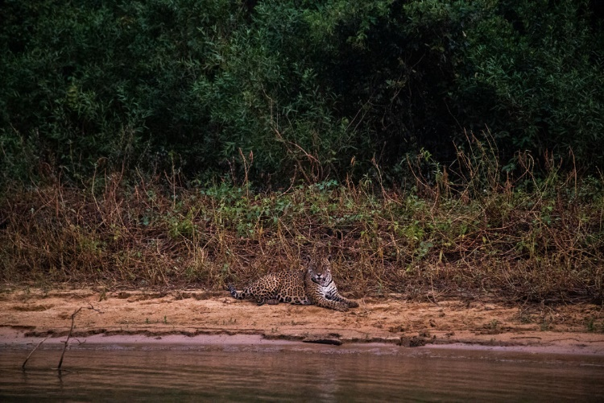
Mr. Tortato knows of three injured jaguars, one with third-degree burns on her paws. All were treated by veterinarians. Now, biologists are braced for the next wave of deaths from starvation; first the herbivores, left without vegetation, and then the carnivores, left without the herbivores.
“It’s a cascade effect,” Mr. Tortato said.
Animal rescue volunteers have flocked to the Pantanal, delivering injured animals to pop-up veterinary triage stations and leaving food and water for other animals to find. Larissa Pratta Campos, a veterinary student, has helped treat wild boar, marsh deer, birds, primates and a raccoon-like creature called a coati.
“We are working in the middle of a crisis,” Ms. Pratta Campos said. “I have woken up many times in the middle of the night to tend to animals here.”
Last week, the O Globo newspaper reported that firefighting specialists from Brazil's main environmental protection agency were stymied by bureaucratic procedures, delaying their deployment by four months.

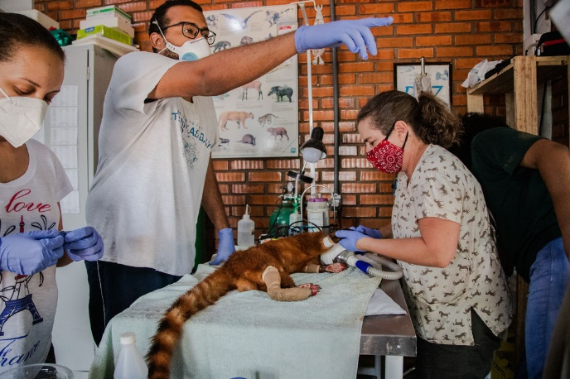
Given the historic scope of the fires, their long-term consequences on the Pantanal are unclear. The ecosystem’s grasslands may recover quickly, followed by its shrublands and swamps over the next few years, said Wolfgang J. Junk, a scientist who specializes in the region. But the forests will require decades or centuries.
Even more critical than the impact of this year’s fires, scientists say, is what they tell us about the underlying health of the wetlands. Like a patient whose high fever signals a dangerous infection, the extent of the wildfires is a symptom of grave threats to the Pantanal, both from inside and out.
More than 90 percent of the Pantanal is privately owned. Ranchers have raised cattle there for hundreds of years, and ecologists emphasize that many do so sustainably. But new farmers are moving in, often with little understanding of how to use fire properly, said Cátia Nunes, a scientist from the Brazilian National Institute for Science and Technology in Wetlands. Moreover, cattle farming in the highlands has put pressure on local farmers to increase the size of their herds, using more land as they do so.
Eduardo Eubank Campos, a fifth-generation rancher, remembers his family using controlled burns to clear the land when he was a boy. He said they stopped after adding an ecotourism lodge to their 7,000 hectare property, which now includes reserves and fields on which they raise about 2,000 head of cattle and horses. This year, thanks to firebreaks, a water tank truck and workers quickly trained to fight fire, they were able to keep the flames at bay. The worst impact was on his ecotourism business, hit first by the coronavirus and then by the wildfires. It brings in three-quarters of his revenue.
Mr. Eubank Campos struggles to understand who would set fires when the land was so dry. “Pantaneiros know this is not the time to do burns,” Mr. Eubank Campos said, using a term for the locals that also conveys a culture built up over centuries ranching in the wetland. “They don’t want to destroy their own land.”
The Brazilian federal police are investigating the fires, some of which appear to have been illegally targeting forests.
Still, when asked about the biggest threat to the Pantanal, Mr. Eubank Campos’s answer highlights the region’s political and cultural fault lines. “I fear those organizations that come here wanting to exploit the issue and eventually ‘close’ the Pantanal, turn it into one big reserve and kick out the Pantaneiros,” he said.
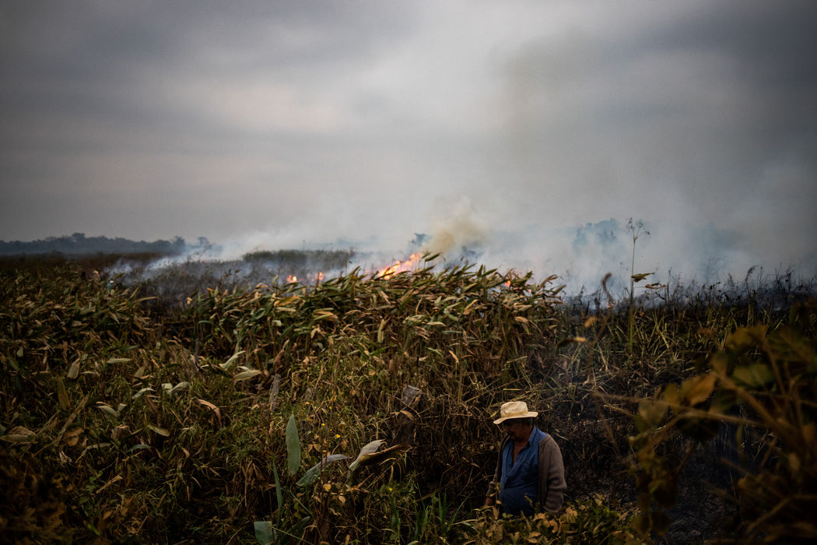
Brazil’s president, Jair Bolsonaro, who campaigned on a promise to weaken conservation regulations, is popular in the region.
But Mr. Eubank Campos agrees with ecologists on a major threat to the Pantanal that comes from its borders and beyond.
Because ecosystems are interconnected, the well-being of the wetland is at the mercy of the booming agriculture in the surrounding highlands. The huge fields of soy, other grains and cattle — commodities traded around the world — cause soil erosion that flows into the Pantanal, clogging its rivers so severely that some have become accidental dams, robbing the area downstream of water.
The rampant deforestation and related fires in the neighboring Amazon also create a domino effect, disrupting the rainforest’s “flying rivers” of precipitation that contribute to rainfall to the Pantanal. Damming for hydroelectric power deflects water away, scientists say, and a proposal to channelize the wetland’s main river would make it drain too quickly.
But perhaps the most ominous danger comes from even further afield: climate change. The effects that models have predicted, a much hotter Pantanal alternating between severe drought and extreme rainfall, are already being felt, scientists say. A study published this year found that climate change poses “a critical threat” to the ecosystem, damaging biodiversity and impairing its ability to help regulate water for the continent and carbon for the world. In less than 20 years, it found that the northern Pantanal may turn into a savanna or even an arid zone.
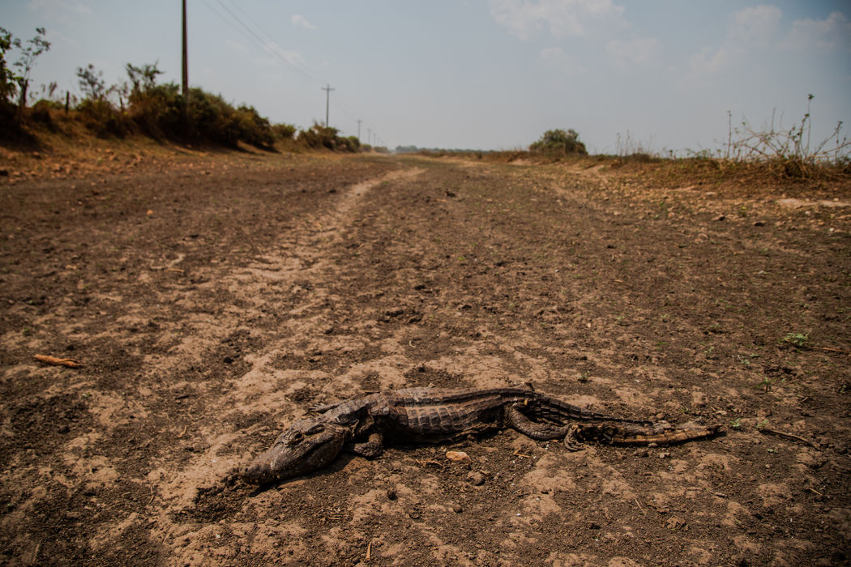
“We are digging our grave,” said Karl-Ludwig Schuchmann, an ecologist with Brazil’s National Institute of Science and Technology in Wetlands and one of the study’s authors.
To save the Pantanal, scientists offer solutions: Reduce climate change immediately. Practice sustainable agriculture in and around the wetland. Pay ranchers to preserve forests and other natural areas on their land. Increase ecotourism. Do not divert the Pantanal’s waters, because its flood pulse is its life.
“Everybody talks about, ‘we have to avoid this and that,’” Dr. Schuchmann said. “But little is done.”
From The New York Times Climate Change Newsletter

More Climate News
Florida Sees Signals of a Climate-Driven Housing Crisis – Home sales in areas most vulnerable to sea-level rise began falling around 2013, researchers found. Now, prices are following a similar downward path. New York Times
Clean Up Your Halloween - Halloween looked a bit different this year because of the pandemic, but there could be a green lining: an opportunity to develop a more sustainable outlook on a typically high-waste holiday. New York Times
Science Shorts ~NPR Short Wave ~ The Science Behind the Headlines
The Tricky Business of Coronavirus Testing on College Campuses | Hit the road with NPR Education Reporter Elissa Nadworny, She’s been on a weekslong road trip to get an up-close view of how colleges across the U.S. are handling the pandemic…
Butterflies Have Hearts in Their Wings. You Won’t Believe Where They Have Eyes | Adriana Briscoe, a professor of biology and ecology at UC Irvine, studies vision in butterflies. As part of her research, she's trained them to detect light of a certain color. She also explains ….
Does Talking to Plants Help Them Grow? | Environmental scientist Heidi Appel explains how plants detect sound – and whether talking to Yours could help them grow big and strong…
Florida Beacon
Published Quarterly by the Florida Association of Environmental Professionals
9

FAEP Group Discount Memberships
Did you know that FAEP provides a discount on our membership to employers who have 5 or more members? If your company or organization qualifies for the Group Membership you save $5 on each FAEP new member or renewing member, lowering the FAEP membership fee from $40 to $35 for everyone from your company or organization. If your company or organization is on this list, you are eligible to join or renew at the discounted Group rate. Some of our member organizations renew all of their employee-members at the same time with a single payment. The FAEP Board would like to extend a thank you to the following employers for supporting their employee’s professional development and the FAEP mission:
AECOM |  | Cummins Cederberg |  |  | GeoSyntec Consultants |  | Orange County EPD
Atkins |  | DRMP, Inc. |  |  | HSW Engineering |  | Terracon
Bio-tech Consulting, Inc. |  | Earth Sciences, Inc. |  |  | Jacobs Engineering |  | TetraTech, Inc.
Broward County |  | EarthBalance |  |  | Johnson Engineering Inc. |  | Turrell, Hall & Associates
Cardno |  | Flatwoods Consulting Group |  |  | Mosaic |  | USF
Clark Environmental |  | Florida Water Management Districts |  |  | MSE Group |  | WGI
 |  | FDEP
Interested in advertising to almost 2000 Environmental Professionals in the FAEP’s newsletter and on our website?  One year sponsorships also get your  organization logo on our webpage!  Sponsorship Rates |  |  |  |  |  | Florida Beacon  Published Quarterly by the  Florida Association of Environmental Professionals  Teri Hasbrouck, Editor  PO Box 7416  St. Petersburg, FL 33734  Email: info@faep-fl.org  If you would like to submit an article to the Beacon contact the editor at info@faep-fl.org.
Size | One Issue |  | One Year Plus Logo on Website
Biz Card | $35 |  | $100
¼ Page | $100 |  | $375
½ Page | $175 |  | $650
1 Page | $250 |  | $900
Florida Beacon
Published Quarterly by the Florida Association of Environmental Professionals
 |  |  |  | 10

