Elva Peppers
President
Project Manager, Senior Biologist
Florida Environmental and Land Services, Inc

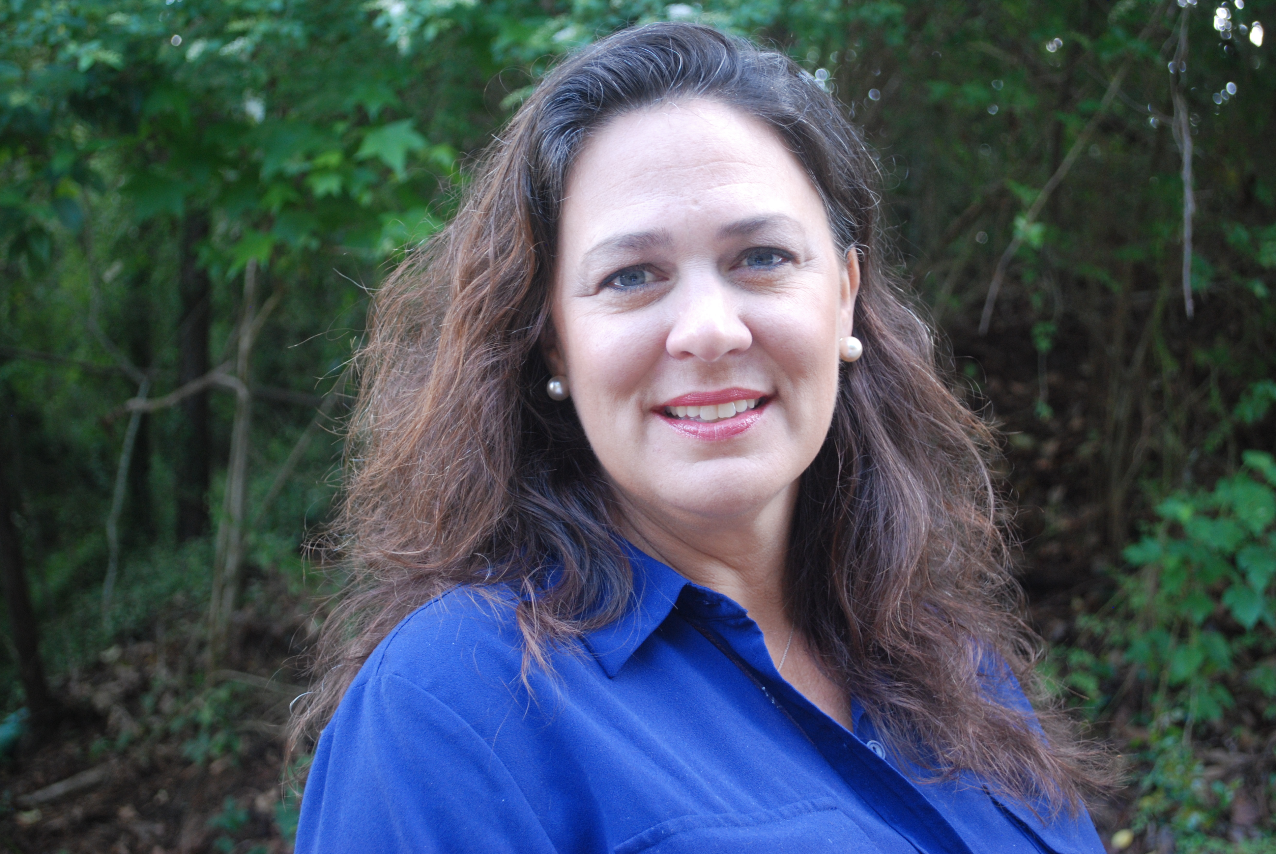  Education  Florida State University, 1990, Bachelor of Science, Biology  Registrations/Licenses  Licensed Environmental Professional (#340)  Software  Microsoft Office  Appointments  Acquisition and Restoration Council, State of Florida  Certifications  Certified Florida Environmental Assessor (#446)  Authorized Gopher Tortoise Agent  Certified Stormwater Pollution Inspector (NPDES) (#1816)  Certified Women Owned/ Minority Business with:  - City of Tallahassee  - Leon County  - Leon County Schools  - State of Florida (Office of Supplier Diversity).  Certified DBE with FDOT  Certified 8(a) Small Disadvantaged Business  Certified SCUBA diver |  | Relevant experience  Ms. Peppers has 25 years of experience in the environmental field and as president  of FELSI, her responsibility includes providing overall project management of all  in-house projects. Her expertise is in performing threatened and endangered species  surveys, habitat classifications, and jurisdictional wetland determinations and  verifications; conducting upland and wetland habitat assessments, critical habitat  assessments and natural feature inventories for private and local government  agencies. She has experience with developing wetland mitigation, enhancement  and hydrological restoration plans, implementing approved mitigation plans and  conducting baseline, semi-annual and annual-monitoring, and maintenance reports;  conducting water quality sampling and monitoring. She is experienced in preparing  Environmental Resource Permit (ERP) and Joint Applications for Works in the  Waters of Florida permit applications and corresponding functional wetland  assessments to obtain regulatory approvals.  She assists private clients, municipalities, and agencies in developing permittable  and sustainable projects. This includes offering services including site selection,  biological field surveys, wetland delineations, natural community inventories,  wetland assessment, protected species surveys, wetland mitigation planning and  design, permitting, compliance and monitoring.  In addition, her experience includes siting studies for natural gas pipeline;  conducting Phase 1 environmental site assessments, and preparing environmental  and land use sections for environmental assessments and environmental impact  statement reports. She has experience in expert testimony in wetland jurisdictional  disputes, training in plant identification and conducting workshops.  Ms. Peppers is familiar with local and state environmental objectives having  worked for FDEP and having experience coordinating with all five water  management districts and the USACE.  Ms. Peppers is an Authorized Gopher Tortoise Agent and is on the State of  Florida’s Acquisition and Restoration Council (ARC).  Professional Affiliations  Past President, Florida Association of Environmental Professionals, Tallahassee Chapter  At Large Board Member Florida Association of Environmental Professionals  Treasurer, Big Bend Contractors Association  Member of the National Association of Women in Construction  Member of the Greater Tallahassee Chamber of Commerce  Member Gadsden County Chamber of Commerce  Member Wakulla County Chamber of Commerce  Training  ANERR Seagrass Restoration Forum  ANERR Living Shorelines Workshop  Weeks Bay Foundation Ecological Restoration Principles and Application Workshop 2  ANERR Sandhills and Ravines Class  Gopher Tortoise Certification Training Program  FEAA Phase I Environmental Site Assessment & All Appropriate Inquiry Training  FDEP SOP Sampling Training for Groundwater, Surface Water, and Wastewater  Ecosystems Management Training, 1996 Hydric Soils of Florida, University of Florida

