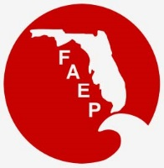 | 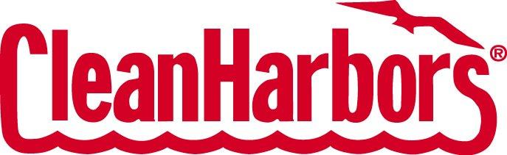  FAEP CHAPTER MEETINGS  JANUARY 2018
Chapter |  | Event | Speaker/Affiliation | Date and Time | Location |  | Contact
Central |  | Networking Social |  | Thurs, Jan 18  5:30 pm – 7:30 pm | World of Beer  Downtown Orlando |  | RSVP to  Jennifer.Cummings@ocfl.net
Northeast |  | Networking Social – Jacksonville Iceman hockey game |  | Wed, Jan 24  7:30 pm | Jacksonville Veterans Memorial Arena |  | RSVP by Jan 10th to  keckert@mechlingeng.com
Northwest |  | Luncheon - What can UWF GEO Data Center do for you and your team? |  | Fri, Jan 19  11:30 am – 1:00 pm | Institute of Human and Machine Cognition  40 S Alcaniz St  Pensacola, FL |  | RSVP to  chobbs@uwf.edu
South |  | No Meeting
Southwest |  | Networking Social |  | Fri, Jan 19  7:00 pm – 9:00 pm | Miller’s Ale House  Gulf Coast Town Center |  | RSVP to  SWFAEP@gmail.com
Tallahassee |  | Luncheon - “Sense of Place” and Economic Development in Tallahassee | Betsy Couch, Executive Director, Knight Creative Communities Institute, and Abena Sackey Ojetayo, Chief Resilience Officer, City of Tallahassee | Wed, Jan 10  11:30 am – 1:00 pm | Beef O' Brady's  1800 Thomasville Rd  Tallahassee, FL |  | RSVP to  egates@genesisgroup.com
Tampa Bay |  | Networking Social |  | Thurs, Jan 18  5:30 pm – 7:30 pm | TBD |  | RSVP to  tbaep@faep-fl.org
Treasure Coast |  | Presentation: US Army Corps of Engineers Permitting Update | Krista Sabin, Senior Project Manager, USACE | Thurs, Jan 25  5:30 pm – 7:30 pm | Loxahatchee River Center  805 US 1  Jupiter FL 33477 |  | RSVP by Jan 22nd to  tcc.faep@gmail.com

NAEP Update

The January 5, 2018 Issue of the National Desk can be found here:
https://naep.memberclicks.net/assets/NationalDesk2018/20180105naepnationaldesknewsletter.pdf

Find stories on the following topics:
- Lead NEPA Story: Court reverses ruling delaying hot-button Maryland project
- Endangered Species Act: Interior to revise listing rules
- Clean Air Act: Government Accountability Office to look at social cost of carbon
- Programmatic NEPA: Bureau of Land Management to study strategies to cut wildfire risk
- NEPA: Environmentalists, states sue over rollback of Bureau of Land Management methane rule

