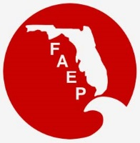 |  | UPCOMING FAEP CHAPTER MEETINGS  MARCH 2017
Chapter | Event |  | Speaker/Affiliation | Date and Time | Location |  | Contact
Central | Networking Social - Oyster Drilling Event' |  |  | Thurs, Mar 23  5:30 pm – 8:00 pm | Reel Fish Coastal Kitchen + Bar |  | RSVP to  Jennifer.Cummings@ocfl.net
Northeast | Member Luncheon – Intro to CHMM and AHMP |  | Chip Carwell, PE, CHMM | Thurs, Mar 16  11:30 am – 1:00 pm | Ed Ball Building, 1st Floor  214 N Hogan St.  Jacksonville, FL 32202 |  | RSVP to  keckert@mechlingeng.com
Northwest | Annual Award Ceremony |  | Awards include Lifetime Achievement and Environmental Professional of the Year | Fri, Mar 10  5:30 pm – 9:00 pm | The Oar House  1000 S Pace Blvd  Pensacola, FL 32502 |  | RSVP to  chobbs@uwf.edu
Northwest | Member Luncheon - FFWCPS Review Process |  | Kristal Walsh, Biological Scientist Florida Fish and Wildlife, Office of Conservation Planning Services | Fri, Mar 17  11:30 am – 1:00 pm | Institute of Human and Machine Cognition, Pensacola |  | RSVP to  chobbs@uwf.edu
South | Annual Symposium |  | Various | Fri, Mar 17 | Florida International University Biscayne Bay Kovens Center |  | RSVP at  www.SFAEP.org
Southwest | Networking Social |  |  | Wed, Mar 15  5:30 pm – 7:30 pm | Big Top Brewery  6111 Porter Way,  Sarasota, Florida |  | RSVP to  Arielle@thanaples.com
Tallahassee | Member Luncheon - Deepwater Horizon Oil Spill |  | Dr. Jeff Chanton, FSU and  Phil Coram, FDEP | Wed, Mar 8  11:30 am – 1:00 pm | Beef O’Brady’s  1800 Thomasville Road  Tallahassee, FL, 32303 |  | RSVP to egates@genesisgroup.com
Tampa Bay | Member Luncheon – Hillsborough 100 Conservation Challenge |  | Betty Jo Tompkins, Hillsborough County Soil and Water Conservation District | Wed, Mar 15  11:30 am – 1:00 pm | Brio Tuscan Grille  2223 North Westshore Blvd Tampa, FL 33607 |  | RSVP to  tbaep@faep-fl.org
Tampa Bay | Networking Social |  |  | Thurs, Mar 23  5:00 pm – 8:00 pm | Four Green Fields  205 Platt Street, Tampa |  | RSVP to  tbaep@faep-fl.org
Treasure Coast | TBA

NAEP Update:

NAEP 2017 CONFERENCE REGISTRATION IS OPEN: Click HERE to Register Online Today!

NAEP MARCH 8, 2017 WEBINAR - Environmental Practice in Flux: Transitioning to the Trump Administration
NAEP Mar 8 2017 webinar-bill me or NAEP Mar 8 2017 webinar-credit card payment

This month’s calendar is sponsored by:
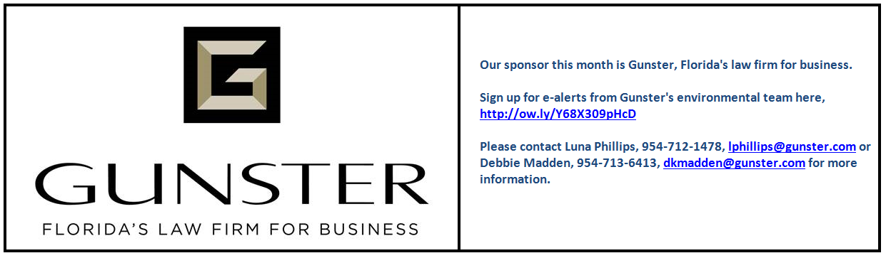

Other events going on in March –

FWC Florida Shorebird Alliance free webinars:
· March 7: Webinar for new surveyors, 1-2pm. Learn the basics of the Breeding Bird Protocol and how to enter surveys in the database.
· March 9: Webinar for rooftop monitors, 1-2pm. Learn the basics of monitoring seabirds and shorebirds on rooftops.
www.flshorebirdalliance.org/get-involved.aspx.

Sunshine Week marks its 12th Anniversary!
March 12th - 18th 2017
Sunshine Week promotes open government and encourages the public to exercise its right to information. In keeping with the spirit of the week, the Florida Department of Environmental Protection will offer training on the use of our records database, Oculus. Training will include navigating the Information Portal and searching our online records repositories for documents.

If you are interested in learning more about Oculus, please send an e-mail to Cathy.Rodriguez@dep.state.fl.us with the number of people in your party, the days of the week that you will be available for training and whether you are interested in beginner’s training or an advanced Oculus course. Training will be held at the Florida Department of Environmental Protection’s Southwest District office located at 13051 N. Telecom Parkway Temple Terrace, Florida 33637. Please contact Cathy Rodriguez for more information: Cathy.Rodriguez@dep.state.fl.us or call 813-470-5714

