Florida Beacon
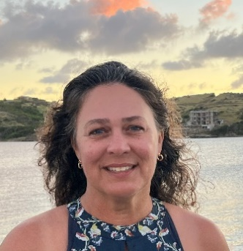  From the President’s Desk  Elva Peppers  Hello FAEP Members, | Florida Association of Environmental Professionals  Winter 2023  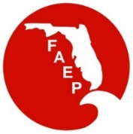
The 2022 year has ended and its a good time to reflect on what we have accomplished during the past year and make some plans for the upcoming year. I would like to thank the efforts of the Board Members on both the state and local chapter levels. Without their vision, hard work and selfless giving of their time and energy, this organization would not be a success.  Some of our accomplishments from this past year include:  1) Hosting the National Association of Environmental Professionals conference in Ft Lauderdale.  2) Updating membership dues and adding a category for Retired Persons to our membership types.  3) Hosting three FAEP Soils Workshops (Tallahassee, Northwest and Treasure Coast Chapters).  4) Hosting one Phase 1 Environmental Site Assessment training (South Chapter)  5) Engaging an additional administrative position to assist chapters with events and coordinate organization content.  6) Holding many, many chapter events including luncheons, socials, community service projects, member appreciation events and other special events.  Looking ahead at 2023 we have many things to look forward to including the 2023 State Conference in Tallahassee on May 11th and 12th. This conference, in the Capital City, will showcase many agency presenters, respected scientists, great field trips, and training workshops. There will be something for everyone from seasoned professionals to those new to the industry. Another goal for this year includes continuing to bring the soils training and Phase 1 ESA training to other chapters around the state at a significant discount to FAEP members. The Board continues to meet monthly to plan improvements and programming for our membership. As always, we appreciate your feedback and ideas.  Happy New Year and Cheers to a great 2023!  Sincerely,  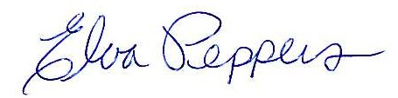  FAEP President (2022 – 2023)  ElvaPeppers@felsi.org | FAEP Board of Directors
 | Elva Peppers – President
 | Ryan Goldman – Past President
 | Gina Chiello – Vice Pres. & TC Chapter
 | Kelley Samuels – Treasurer
 | Jen Savaro – Secretary & SO Chapter
 | Bruce Hasbrouck - Parliamentarian
 | Amy Guilfoyle – CN Chapter
 | David Wood – NE Chapter
 | Michael Cobb - NW Chapter
 | Christina Hall – SW Chapter
 | Brian Bendis – TB Chapter
 | Susan Martin – At Large Member
 | Joe Penta – At Large Member
 | Jane Gregory – At Large Member
 | Don Medellin – At Large Member
 | Tim Perry – NAEP Representative
Check the last page of our newsletter to determine if you qualify for a discount on your FAEP membership!
New FAEP membership rate for Retirees offered!
Find out more about FAEP
Member’s Benefits at our website:
WWW.FAEP-FL.ORG

Florida Beacon
Published Quarterly by the Florida Association of Environmental Professionals
1

Treasure Coast Chapter
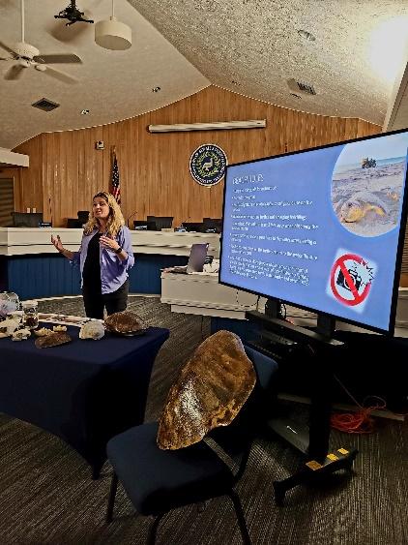
The Treasure Coast Chapter (TCC) of FAEP has a wide geographic range, extending from Indian River County in the far north, through Okeechobee County to the west, then south through St. Lucie, Martin, and Palm Beach Counties. For a board of less than a dozen people, it can be challenging to plan and orchestrate events that cover this whole territory and engage our entire membership. This summer, we set out to engage the professional community in under-represented areas of our Chapter to re-engage participation and help increase membership through four key events. Our June event was held in Port St. Lucie (St. Lucie County) and featured a presentation on public engagement around green infrastructure and living shorelines by Dr. Vincent Encomio, the Florida Sea Grant Extension Agent at the University of Florida. Next, in July, we held our 7th annual sea turtle nesting walk on Hutchinson Island in Martin County, hosted by Ecological Associates, Inc. This event usually draws up to 40 people and is always a fun family-friendly event. This was followed in August by our farthest north event yet to date, a spoil island clean- up at IR-6 in Sebastian with the Florida Department of Environmental Protection (FDEP) Indian River Lagoon Aquatic Preserves Program (IRLAP), who partnered with us to help develop and carry out this amazing opportunity for our friends and members.
For the August event, we had over 30 participants attend including members from the Central Florida FAEP Chapter, the U.S. Fish and Wildlife Service (USFWS), FDEP, the Florida Fish and Wildlife Conservation Commission, and many others from additional public and private organizations. As with coordinating many events, one challenge was transport to the island, which luckily, the FDEP IRLAP team was able to solve by ferrying us on their boat. Once gathered at the island, we distributed buckets and trash bags to the crew to disperse and collect as much trash as possible. We covered the entire island in small groups, with the USFWS staff tackling some of the larger pieces of wooden debris found on the island. We ultimately removed hundreds of pounds of waste, which was kindly transported off the island by FDEP and the USFWS. Our event was capped off by a few rounds of beers and some snacks at Mash Monkeys, a local brewery who had reached out and offered to host an event for us. Cont’d on next page

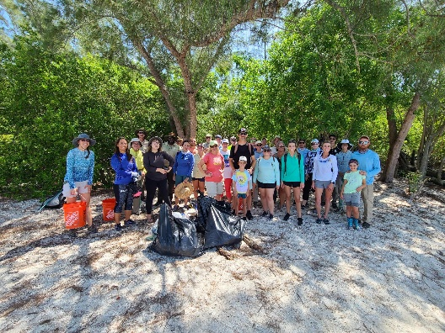
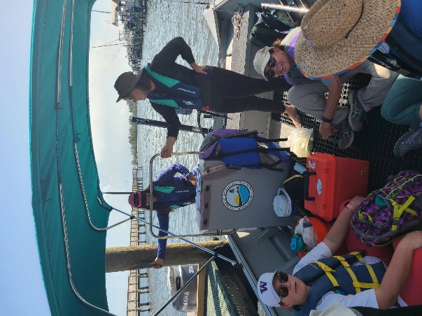
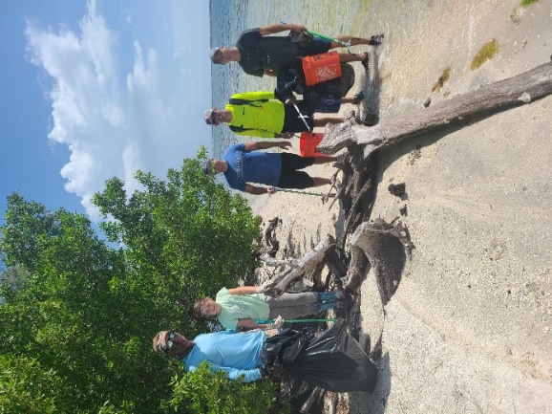
Florida Beacon
Published Quarterly by the Florida Association of Environmental Professionals
2

Treasure Coast Chapter Continued
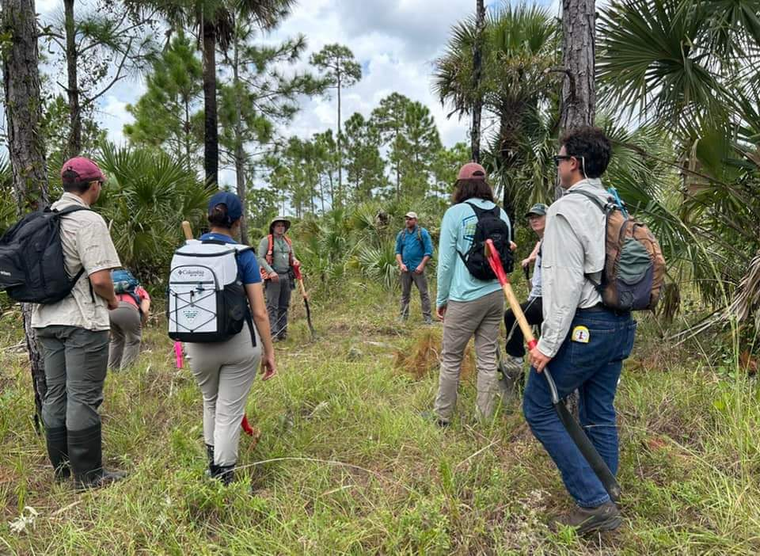
In order to promote participation by professionals in the western portion of our chapter territory, the TCC teamed up with the state FAEP in October to offer a Hydric Soils Training Workshop at Dupuis Reserve. The Dupuis Reserve is located approximately 15 miles from Okeechobee County and features some unique and beautiful habitats, perfect for soil sampling. We offered 1-day and 2-day training workshops to all professionals (members and non-members). These Hydric Soils Workshops were well attended and were a huge success. The workshops provided participants with certified educational credits (CEUs) that can used for professional certifications, such as Professional Wetland Scientist. Some participants took advantage of discounted workshop rates by becoming Chapter members which resulted in growing our membership base.
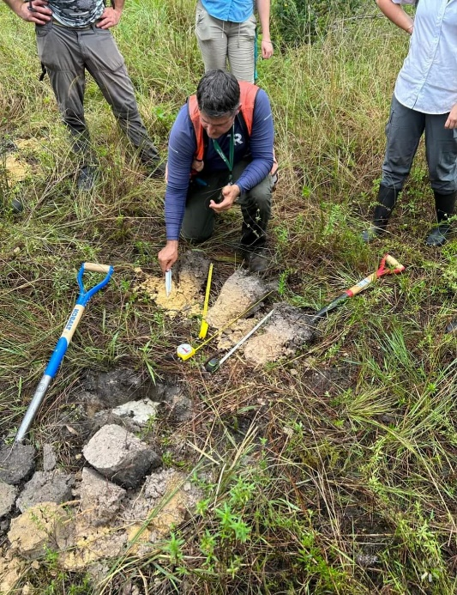
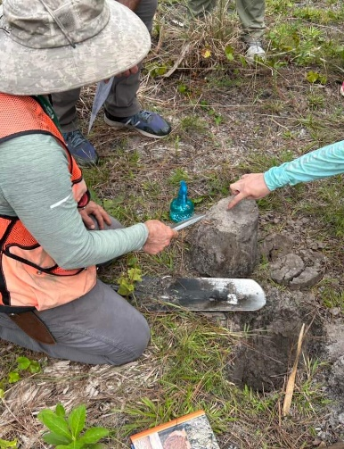
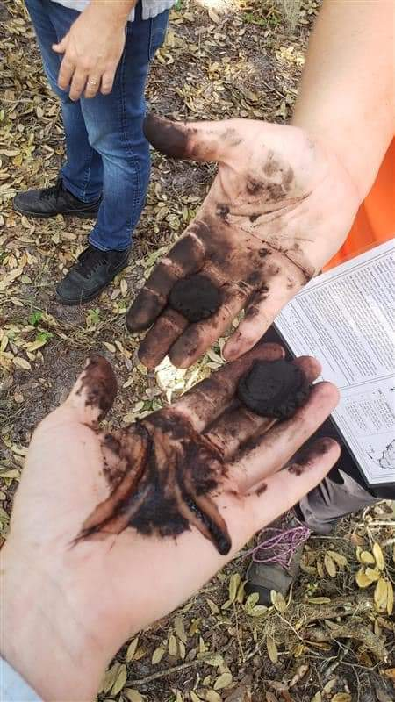

Finding a way to engage a dispersed membership can be difficult. One way TCC FAEP tackles this is to ask for feedback from our members regularly. Questions we typically ask are:
- What days of the week work best for you to attend an event?
- In what geographic locations are you most likely to attend an event?
- What topics are you interested in hearing about?
- Do you prefer virtual or in-person events?
We recognize it’s impossible to please everyone all the time, but we try hard to include a diversity of topics and locations at each monthly event and at our annual event so that we can touch each part of our membership during the year.
Florida Beacon
Published Quarterly by the Florida Association of Environmental Professionals
3

Register today for the FAEP Symposium scheduled for May 11th and 12th in Tallahassee! Consider joining the FAEP today to save $60 on your conference registration and to also enjoy the benefits of FAEP Membership throughout the year! For information on registering for the conference, as well as the call for abstracts, and sponsor and exhibitor opportunities, visit the website for the 2023 FAEP Symposium. See you there!
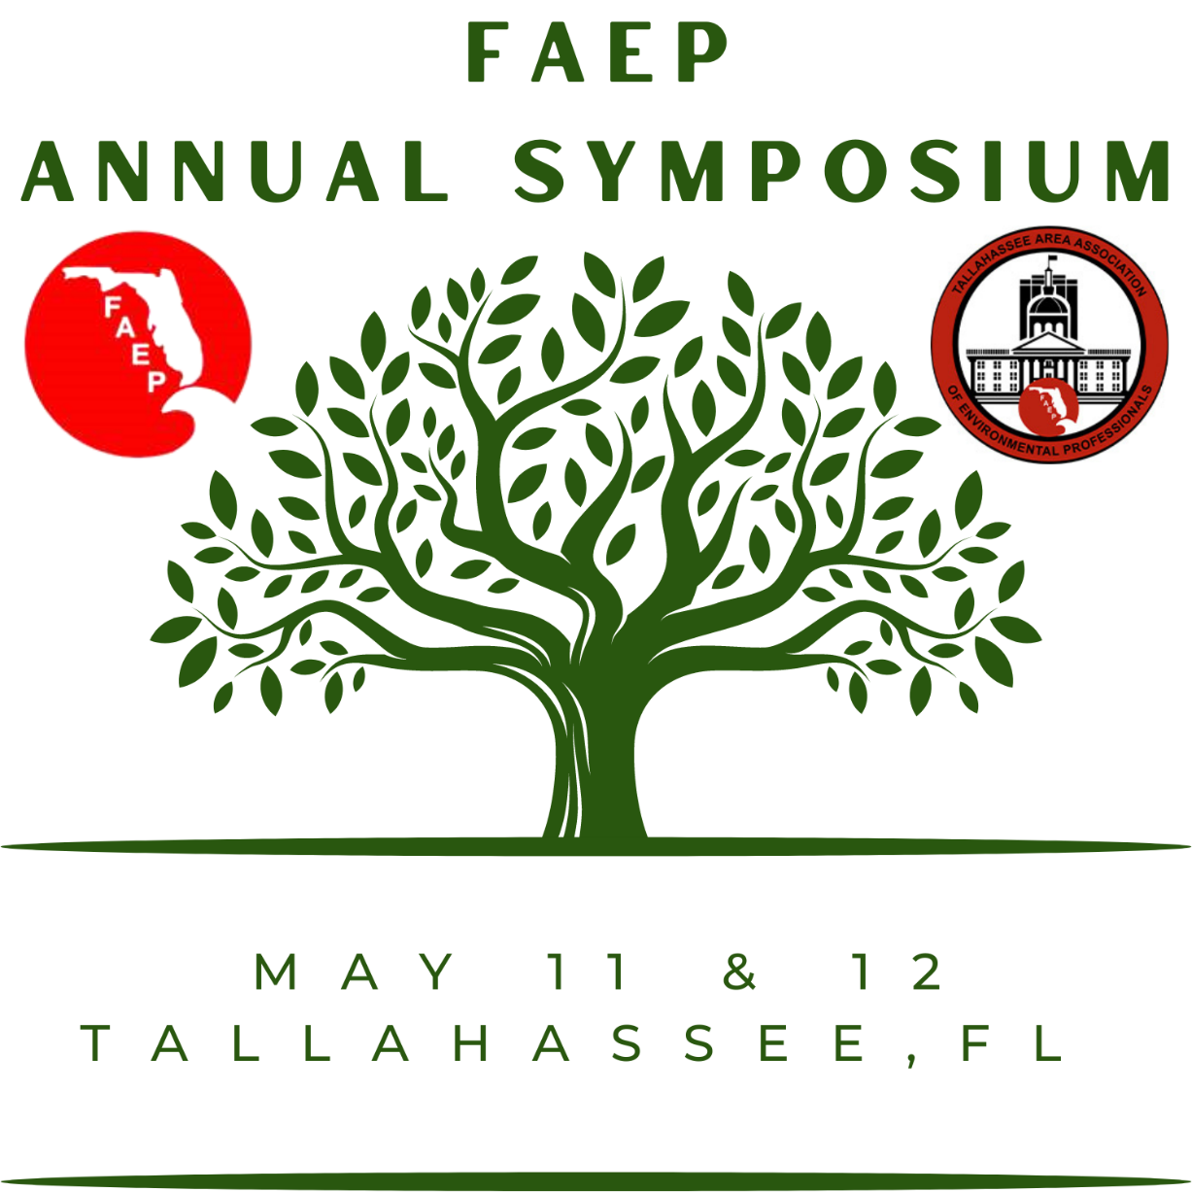
Florida Beacon
Published Quarterly by the Florida Association of Environmental Professionals
4

 | ABCEP
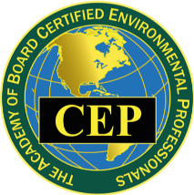
The Academy of Board Certified Professionals (ABCEP) is the certifying body for NAEP and the lead organization certifying environmental professionals; maintaining exemplary standards of ethics and technical practice; and supporting individuals, our profession, and the public relying upon our services. It is a board-certified recognition.
Beyond the acknowledgement by your peers, earning and maintaining the Certified Environmental Professional (CEP) designation is beneficial as a key differentiator when bidding on projects. It also opens new doors personally and professionally.
ABCEP would like to enhance the CEP (and CEP-IT) by growing our numbers and raising the awareness and value of the credential. If interested, you can find more details about the CEP and the application process on our website https://www.abcep.org. If you email the office (office@abcep.org), our Administrator will follow up to see if you have additional questions about the application process and offer to assign a mentor to help guide you through it.
The initial CEP application fee is typically $200. ABCEP is offering a 10% discount through the end of 2020 reducing the initial CEP application fee to $180. This is a great time to submit your application! We also have a CEP-IT application for those that don’t quite meet the CEP requirements.
Making the decision to pursue a certification can feel like a daunting task, but in this climate, having the designation after your name can prove that crucial differentiator. Please share this with anyone in your office that might be interested.
NAEP
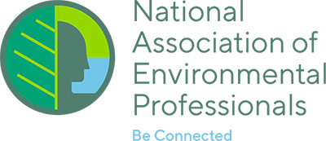
CALL FOR ARTICLES FOR THE ENVIRONMENTAL PRACTICE BULLETIN
The NAEP Environmental Practice Bulletin is published four times a year and emailed to all NAEP members. The newsletter is published in mid-February, May, August and November. Deadline for submissions is the end of the month prior to publication. NAEP is always looking for articles for this great practitioner-based publication. Consider providing NAEP’s nationwide audience a bit of your professional experience and insight. For more information about publishing in the Environmental Practice Bulletin visit: https://www.naep.org/publications.
Upcoming Conferences and Workshops
Event |  | Date | Place
METRA E2 Day |  | Feb. 9, 2023 | Winter Park, FL
Florida Water Environment Association In-Person Seminar |  | Feb. 22, 2023 | Clearwater, FL
National Association of Environmental Professionals |  | May 7 – 10, 2023 | Phoenix, AZ
FAEP Annual Symposium |  | May 11 – 12, 2023 | Tallahassee, FL
37th Annual Summer School |  | July 18 - 21, 2023 | Naples, FL
Southwest Florida Water/Wastewater Exposition |  | TBA
Florida Local Environmental Resource Agencies |  | June 6 – 9, 2023 | Orlando, FL
FAEP shares information about conferences pertaining to the environmental professions. FAEP does not endorse any of the referenced conferences.
Florida Beacon
Published Quarterly by the Florida Association of Environmental Professionals
5

Science Shorts ~NPR Short Wave~ The Science Behind the Headlines
Scientists discover fantastical creatures deep in the Indian Ocean | Yi-Kai Tea, a biodiversity research fellow at the Australian Museum in Sydney, has amassed a social media following as @KaiTheFishGuy for his sassy writing and gorgeous photos of fish and other wildlife.
6 doctors swallowed Lego heads for science. Here’s what came out | As an emergency physician at Western Health, in Melbourne, Australia, Dr. Andy Tagg says he meets a lot of anxious parents whose children have swallowed Lego pieces. Much like Andy so many years ago, the vast majority of kids simply pass the object through their stool within a day or so. But Andy and five other pediatricians wondered, is there a way to give parents extra reassurance ... through science?
Meet the mathematical minds behind Oscar-nominated “Everything Everywhere All At Once” | Film directors Daniel Kwan and Daniel Scheinert (collectively: Daniels) reimagined the multiverse movie in their breakout film Everything Everywhere All At Once. Tuesday, the film received 11 Oscar nominations for the 95th Academy Awards, including best picture and best director. This episode, the Daniels share how science played a starring role.
What does our perception of time have to do with climate change?  A lot. | Most people are focused on the present: today, tomorrow, maybe next year. Fixing your flat tire is more pressing than figuring out if you should buy an electric car. Living by the beach is a lot more fun than figuring out when your house might be flooded by rising sea levels.
Did you know?
Licensure of Environmental Professionals by the State of Florida was one of FAEP’s missions during formation in 1987. It was discussed while goal setting during the May 1987 Board meeting. According to the meeting minutes, one of the intents and functions of FAEP was to “encourage state licensure and regulation of those engaged in the environmental profession.” Several dedicated Board members focused on achieving that goal.
Once FAEP obtained 501(c)3 status, we were unable to lobby or pursue specific legislation. As a result, the Environmental Professionals Action Coalition (EPAC) was established to pursue licensure. In 1997 (yes, it took ten years) we secured a sponsor and House Bill 625 was submitted to establish licensure of Environmental Professionals through the Department of Business and Professional Regulation. After many trips to Tallahassee for meetings with legislators, there were concerns the bill was too broad and that the practice of environmental management was not well defined.
EPAC pivoted, secured a sponsor in the Senate, and submitted a revised version which became a joint Senate/House Bill 625 entitled “An act relating to the practice of Professional Biology”. We had legislative committee meetings, addressed their concerns, and met with many senators and representatives. Considering the impact of a newly licensed profession, we also reached out to leaders of Florida Department of Environmental Regulation and Florida Department of Natural Resources (prior to the agencies joining) as well as Florida Game and Freshwater Fish Commission, Florida Department of Transportation. Recognizing that the bill could affect the business of environmental services, we met with several county officials and other user groups such as procurement managers.
As with most bills, the bill did not make it out of committee and did not reach a floor vote. There were concerns from several established programs that we would be signing and sealing jurisdictional determinations, contamination assessments, remediation plans, wetland mitigation plans, and other documents currently signed by other licensed professionals.
In hindsight, the effort was very beneficial in raising awareness of our profession. As most of the communication was face-to-face meetings, lasting friendships were established through the many hours of debating key issues and writing the bill’s text. If you would like a copy of the bills, please feel free to contact me at Bruce@HasbrouckEnv.com.
Florida Beacon
Published Quarterly by the Florida Association of Environmental Professionals
6
FAEP Sponsors

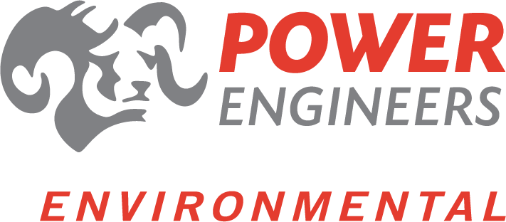

Florida Beacon
Published Quarterly by the Florida Association of Environmental Professionals
7

The FAEP Board of Directors would like to extend a big THANK-YOU
to the organizations who continue to support FAEP
with group memberships for five or more of their employees.
AECOM |  | EarthBalance |  |  | Verdantas |  | SurvTech, Inc.
Atkins |  | EPC Hillsborough County |  |  | Johnson Engineering Inc. |  | Terracon
Bio-tech Consulting, Inc. |  | Flatwoods Consulting Group |  |  | Lewis, Longman, & Walker, P.A. |  | Tetra Tech, Inc.
Broward County |  | Florida Water Management Districts |  |  | Mosaic |  | Turrell, Hall & Associates
Clark Environmental |  | FDEP |  |  | Orange County EPD |  | Wantman Group, Inc.
Cummins Cederberg |  | GeoSyntec Consultants |  |  | Passarella  & Associates |  | WRA Engineering
DRMP, Inc. |  | GHD |  |  | Stantec Consulting
Did you know that you can arrange to renew all of your employees at one time?
If your employer would like to take advantage of the Group Membership discount*
and utilize FAEP’s company invoicing services please email info@faep-fl.org.
*GROUP MEMBERSHIP Each group membership will be for a minimum of 5 qualified employees.
Group memberships are available to corporations, government agencies, and/or other entities involved in and related to the environmental profession. Employers that do not have 5 or more employees who are members can join as General or Associate members. The cost of each Group Membership is $45.
Interested in advertising to almost 2000 Environmental Professionals in the FAEP’s newsletter and on our website?  One year sponsorships also get your organization logo on our webpage!  Sponsorship Rates |  |  |  |  |  | Florida Beacon  Published Quarterly by the  Florida Association of Environmental Professionals  Teri Hasbrouck, Editor  PO Box 7416  St. Petersburg, FL 33734  Email: info@faep-fl.org  If you would like to submit an article to the Beacon contact the editor at info@faep-fl.org.
Size | One Issue |  | One Year Plus Logo on Website
Biz Card | $35 |  | $100
¼ Page | $100 |  | $375
½ Page | $175 |  | $650
1 Page | $250 |  | $900
Florida Beacon
Published Quarterly by the Florida Association of Environmental Professionals
8

